Name

Mathematics Stage 5 Paths
Circle Geometry

Book 1 |  | Version: 261008  Feedback:  https://MrDingMaths.com
Contents
Syllabus Content 2
Learning Intention 3

Syllabus Content
MA5-CIR-P-01 applies deductive reasoning to prove circle theorems and solve related problems
Prove and apply angle and chord properties of circles
- Apply terminology associated with angles in circles
- Identify the arc on which an angle at the centre or circumference stands
- Demonstrate that at any point on a circle there is a unique tangent to the circle, and that this tangent is perpendicular to the radius at the point of contact
- Prove chord properties of circles
- Prove angle properties of circles
- Apply chord and angle properties of circles to find unknown angles and lengths in diagrams
Prove and apply tangent and secant properties of circles
- Prove tangent and secant properties of circles
- Apply tangent and secant properties of circles to find unknown angles and lengths in diagrams

Features of Circles

- Identify Features of circles
Feature | Definition | Example(s)
Circumference | The circumference of a circle is the perimeter, or distance around the outside of a circle.
Arc | An arc is a part of the circumference.
Centre | All points on the circumference is the same distance from the centre.  The real definition of a circle is: a shape made by connecting all points an equal distance from the centre.
Tangent | A tangent is a straight line that touches the circumference at a single point without entering the circle.
Chord | A chord is a straight line that goes from one point on the circumference to another point
Diameter | The diameter is a special chord that goes through the centre of the circle.
Radius | The radius is a line connecting the centre of a circle to the circumference. It is half the diameter.
Segment | A segment is the area between a chord and the circumference.
Sector | A sector is the area between two radii. | Quadrant: semicircle

- Summary of Circle Features
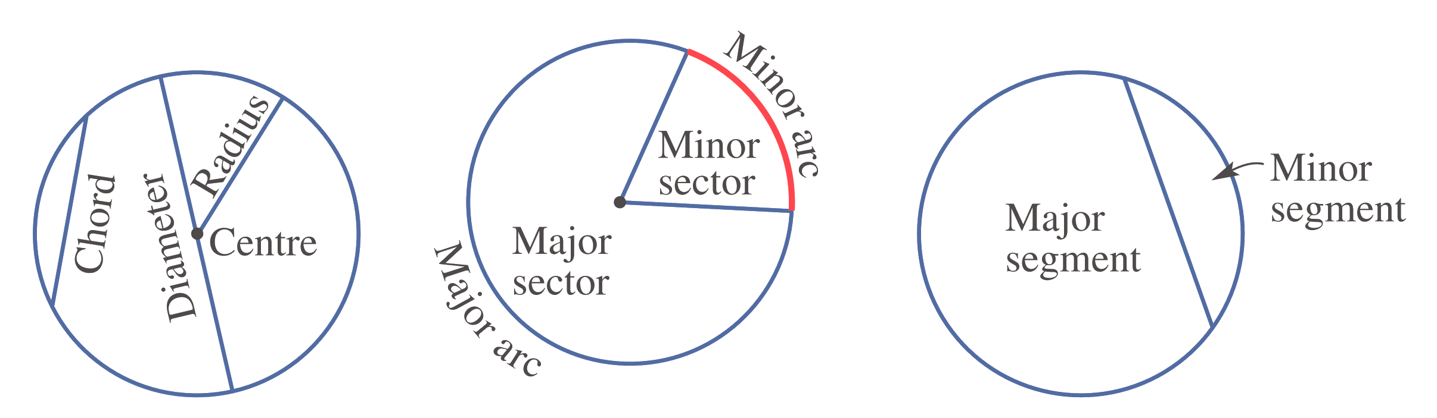

- Circumference Radius Diameter
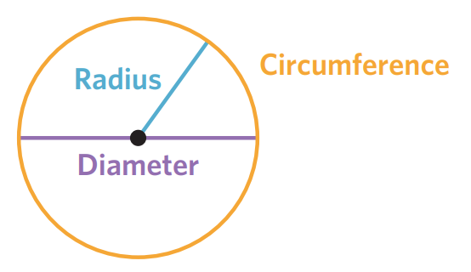

- Circumference is a circle’s perimeter.
- A radius is a straight line from the centre to the circumference.
- A diameter is a straight line through the centre, connecting two points on the circumference.
- The radius is half the diameter; the diameter is double the radius.

- Distinguish between radius and diameter
For each circle, identify whether the straight lines show the radius, diameter, or neither.
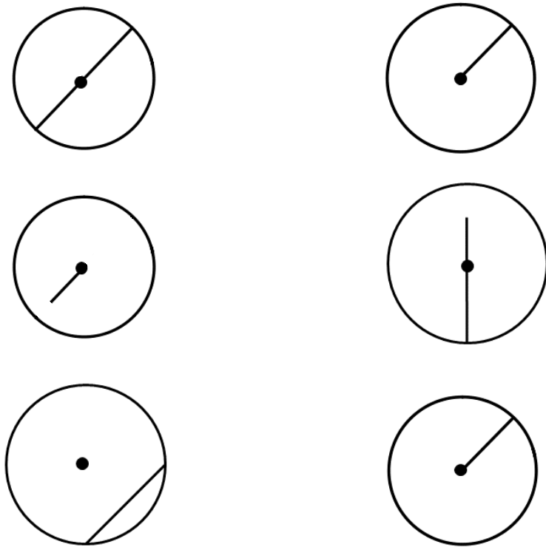  Radius  Diameter  Neither | Radius  Diameter  Neither
Radius  Diameter  Neither | Radius  Diameter  Neither
Radius  Diameter  Neither | 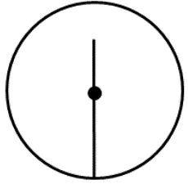  Radius  Diameter  Neither
Radius  Diameter  Neither | Radius  Diameter  Neither

Foundation
- Complete the sentences.
  - The circumference is the ……………… of a circle.
perimeter
  - The radius is a straight line connecting the ……………………… to the ……………………
Centre, circumference
  - The diameter is a straight line connecting two points on the ………………………, passing
through the ……………………
circumference, centre
  - The diameter is ………………… the length of the radius.
double
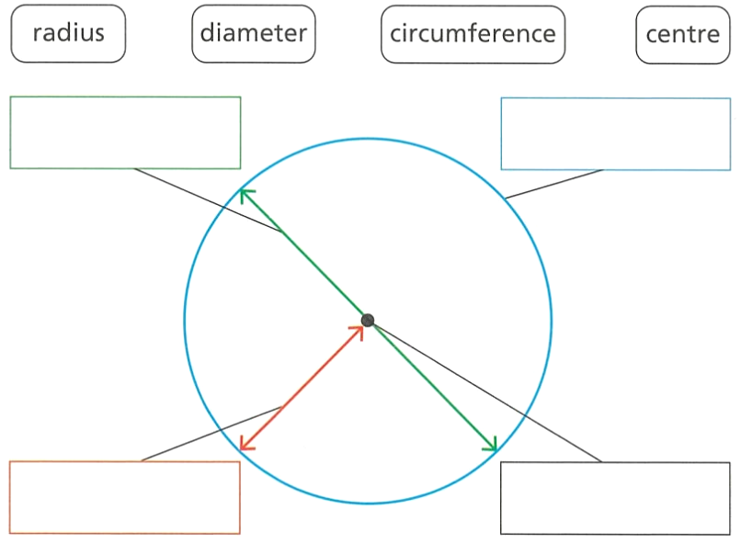
- Label these parts of the circle.

From top left: diameter, circumference, centre, radius

- Circle which of these (a, b, or c) show a radius.
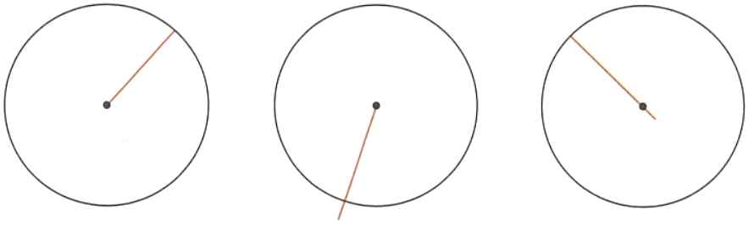

A
- Circle which of these (a, b, or c) show a diameter.
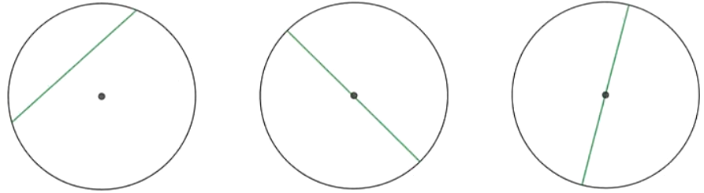

B

- Complete the table.
Radius | Diameter
4 cm | 8 cm
50 mm | 100 mm
12.5 cm | 25 cm
3.4 cm | 6.8 cm
$$\frac{3}{4} cm$$ | $$\frac{6}{4}=\frac{3}{2} cm$$

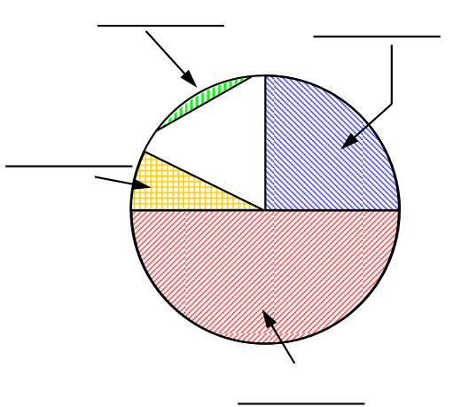
- Name the parts of the circle, then complete the sentences.
Answer to diagram, from top left: segment, quadrant, semicircle, sector
  - Pizzas are usually sliced into ………………………
sectors
  - A …………………… has a 90-degree angle.
quadrant
  - Two ……………………… make a semicircle.
quadrants
  - An arc and two radii make a ………………………
sector
  - The …………………… is a line through the circle that may not touch the centre.
chord
  - The area between a chord and the circumference is called the ……………………
segment
  - A ……………………… has the circle’s diameter as one of the sides.
Semicircle

- Name the highlighted parts of the circle.
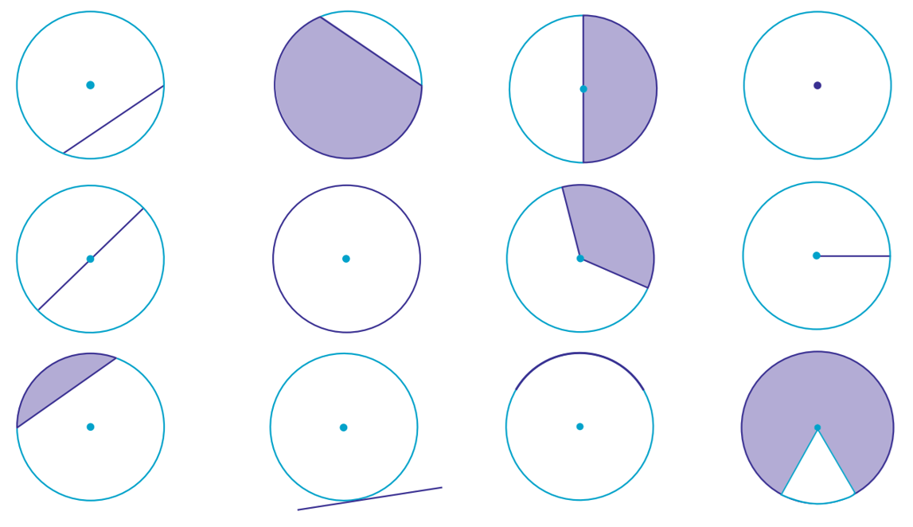  chord | segment | semicircle | centre
diameter | circumference | sector | radius
segment | tangent | arc | sector

Arcs and Angle at the Centre

- Arcs and Angle at the Centre
- An arc/chord subtends (or forms) an angle at the centre and the circumference of a circle.
- When an angle is subtended by an arc, we say it's standing on that arc.
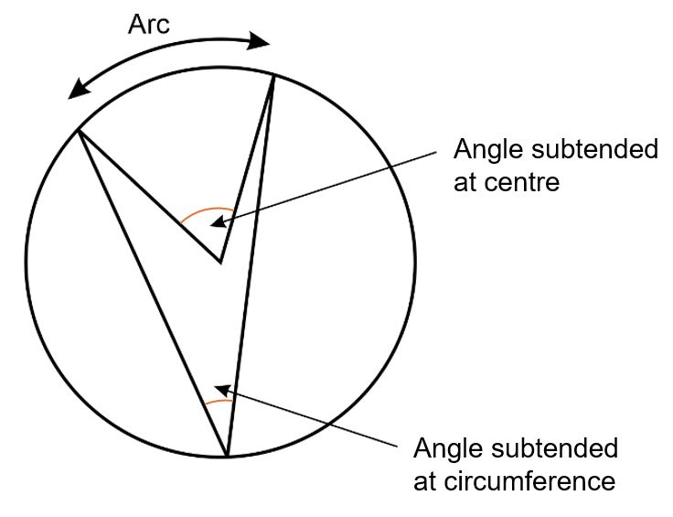

- Identify angle subtended by a chord
Refer to the diagram. Label two angles subtended by chord AB at the circumference $θ$.
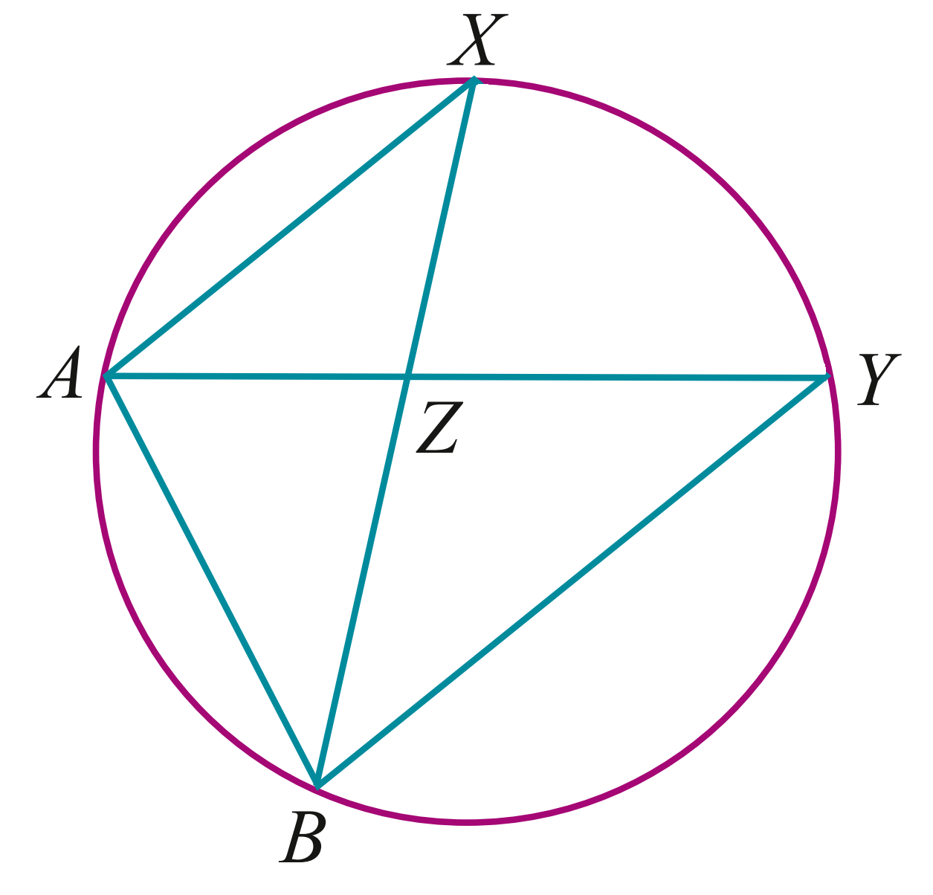
$$θ$$
$$θ$$
$∠AXB$ and $∠AYB$

Refer to the diagram.
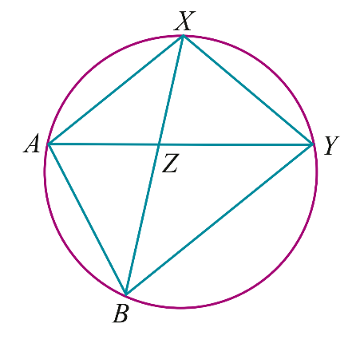
Label two angles $θ$ subtended by chord XY
at the circumference.

$∠XAY$ and $∠BBY$
Label two angles $α$ subtended by chord AY
at the circumference.

$∠AXY$ and $∠ABY$

Refer to the diagram. O is the centre of the circle. AB is a chord.
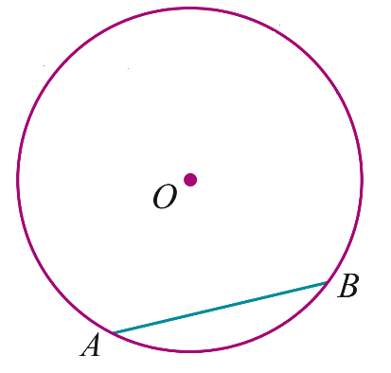
Label the angle $θ$ subtended at the centre by AB.
Draw an angle $α$ subtended at the circumference by AB.

Foundation
- Name the features of circles shown.
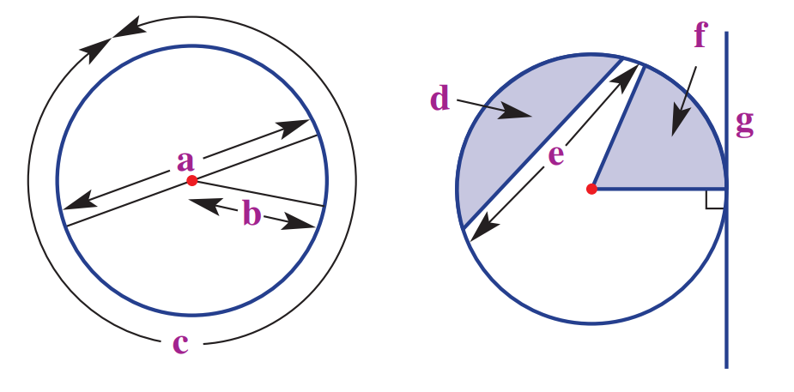
diameter

radius

circumference

segment

chord

sector

tangent
- Give the size of the angle in this circle subtended by the following:
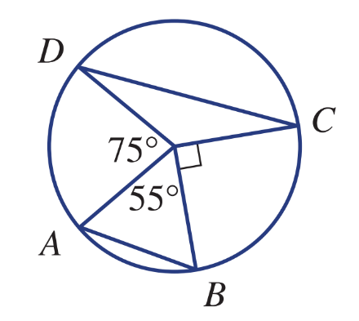
  - Chord AB
55°
  - Minor arc BC
90°
  - Minor arc AD
75°
  - Chord DC
140°

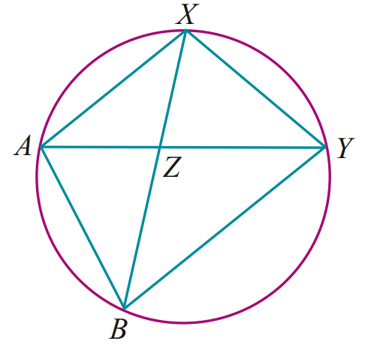
- Name two angles subtended by chord BX at the circumference.

$∠XAB$ and $∠XYB$
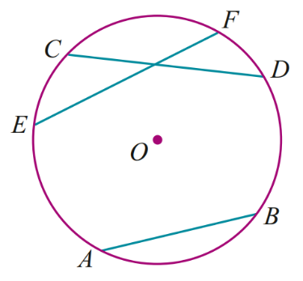
- O is the centre of the circle.
Draw and name the angle subtended at the centre by each of these chords.
  - CD
$$∠COD$$
  - EF
$$∠EOF$$

- Use each of the following words to fill in the sentences below. Some of the words may be used more than once.
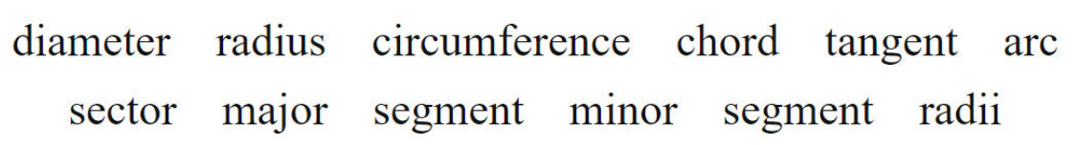

  - A line that goes from the centre of the circle to the edge is called …………………
radius
  - The distance around the edge of a circle is called the …………………
circumference
  - Any line that touches the circumference of a circle on the outside once is called a …………………
tangent
  - A ………………… is a line that cuts the circle into 2 segments: the ………………… ……………… and the ………………… …………………
chord, major segment, minor segment
  - An ………………… is the distance along the circumference between two points.
arc
  - 2 radii cut out a ………………… of the circle
sector
  - The ………………… is twice the …………………
Diameter, radius
  - A ………………… is a ………………… if it passes through the centre of the circle.
Chord, diameter
  - The area of the ………………… plus the area of the ………………… is equal to the area of the whole circle.
Minor segment, major segment
  - A line that connects one point on the circumference to another is called a …………………
Chord

- Identify the isosceles triangles in the diagrams below.
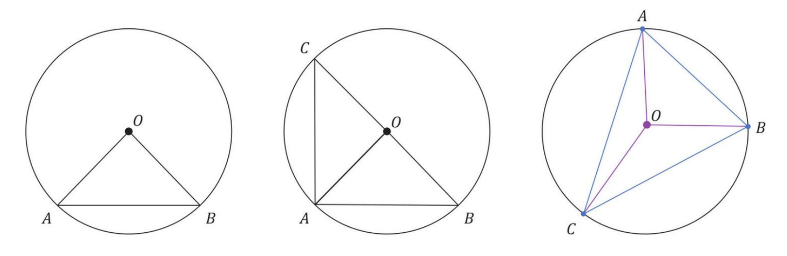  $$ΔAOB$$ | $ΔAOB$ and $ΔCOA$ | $$ΔAOB, ΔBOC, ΔAOC$$

Development
- Name two angles subtended by the same arc AC in these circles.
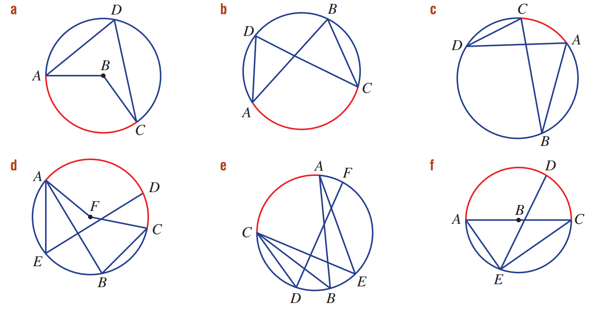  $$∠ABC, ∠ADC$$ | $$∠ADC, ∠ABC$$ | $$∠ABC, ∠ADC$$
$$∠AFC, ∠ABC$$ | $$∠AEC, ∠ABC$$ | $$∠ABC, ∠AEC$$

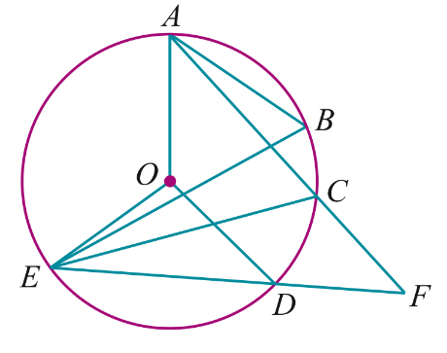
- Name the chord that subtends each of these angles.
  - $∠EOD$
ED
  - $∠CAB$
CB
  - $∠ABC$
AC
  - $∠EFA$
AE
  - $∠EDC$
EC

- Name the angle subtended by chord AB at the circumference in:
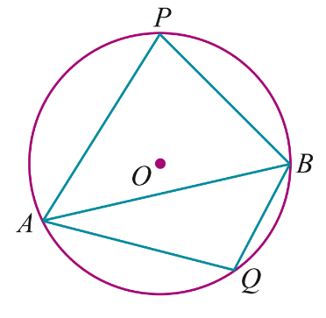
  - The major segment
$$∠APB$$
  - The minor segment
$$∠AQB$$

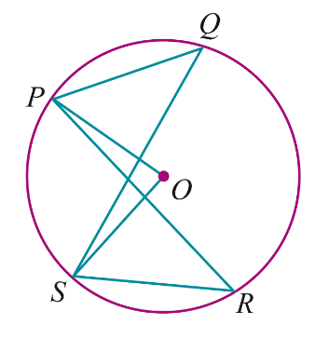
  - Name the angle at the centre subtended by the arc PS.
$$∠POS$$
  - Name an angle at the circumference on the arc PS.
$∠PQS$ or $∠PRS$
  - Name two angles standing on the arc QR.
$∠QPR$ and $∠QSR$

Chord Properties

- Chord Properties
Equal chords subtend equal angles at the centre.  If AB = CD,  then ∠AOB = ∠COD | Equal chords are equidistant from the centre.  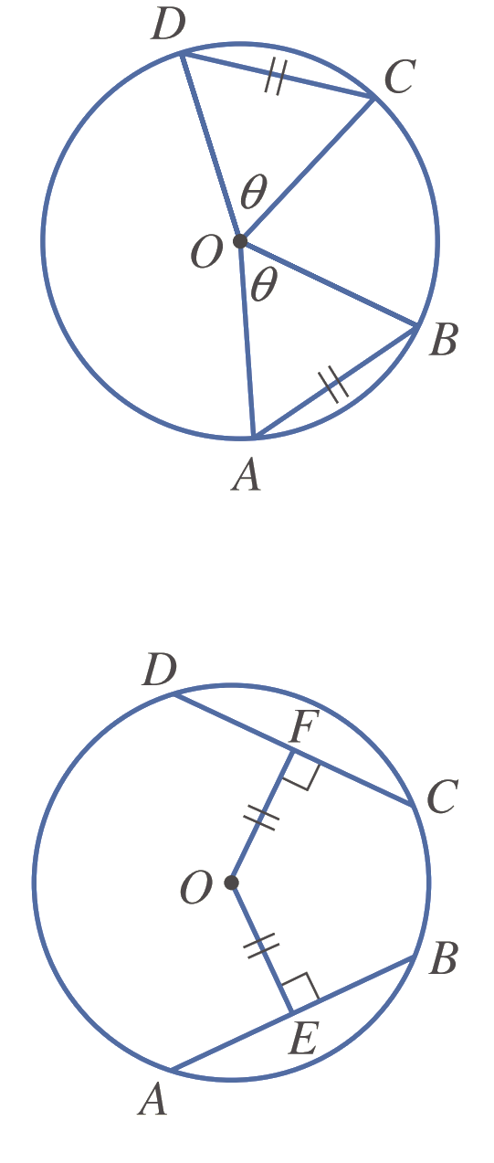  If AB = CD,  then OE = OF | The perpendicular from the centre of a circle bisects the chord.  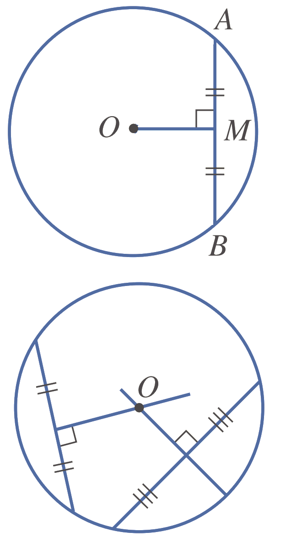  If OM ⟂ AB,  then AM = BM
The perpendicular bisector of a chord passes through the centre. | When 2 circles intersect, the line joining their centres bisects their common chord at right angles.  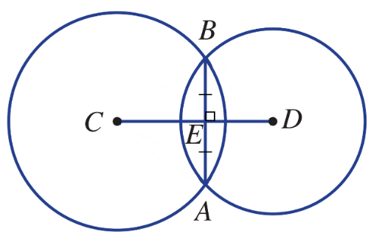

- Example Apply chord properties to find unknown values
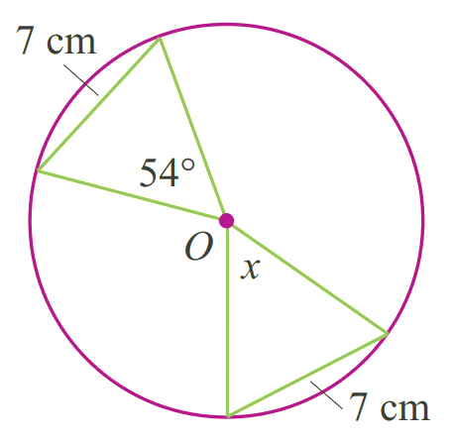  $x=54°$  (Equal chords subtend equal angles at centre) | 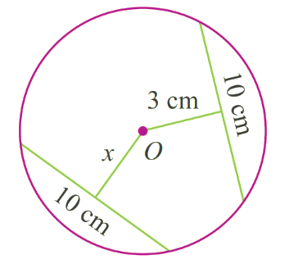  $x=3$ cm  (Equal chords equidistant from centre)

- Guided Practice
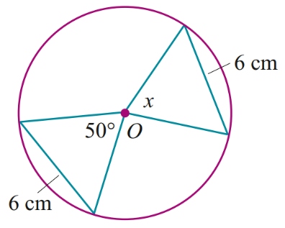  $$50°$$ | 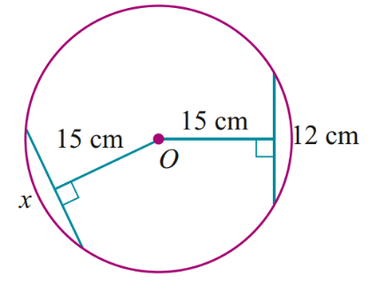  $12$ cm

Foundation
- For each part, find the required information. You do not need to give reasoning.
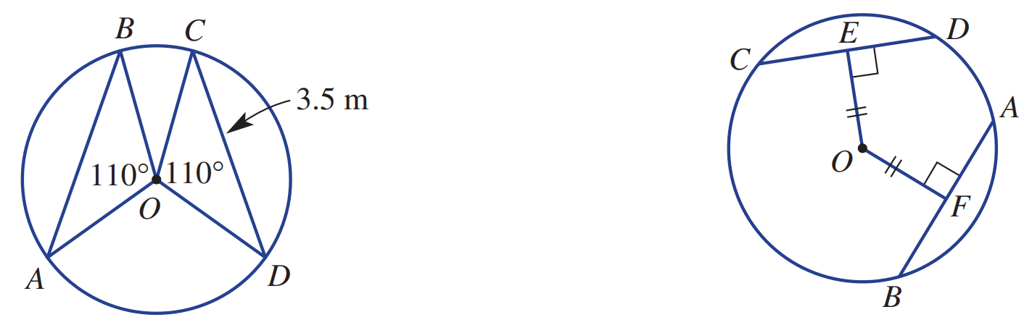  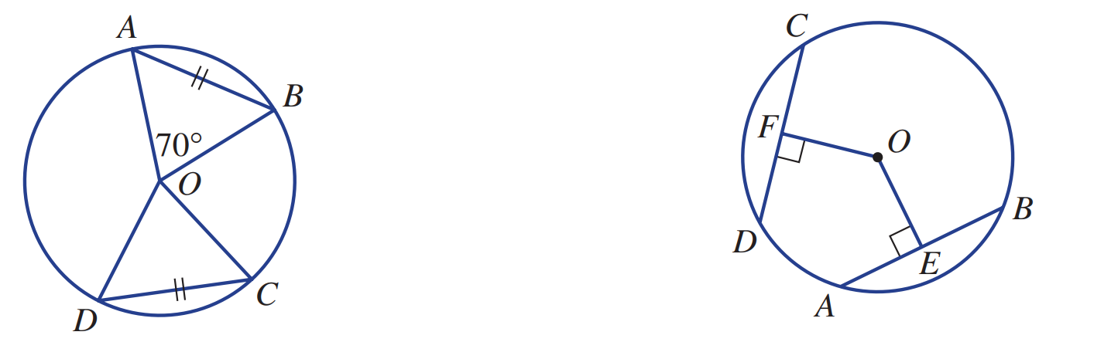  - Given AB = CD and ∠AOB = 70°,  find ∠DOC.  70° | - Given AB = CD and OF = 7.2 cm,  find OE.  7.2 cm
- Given OZ ⟂ XY, XY = 8 cm and  ∠XOY = 102°, find XZ and ∠XOZ.  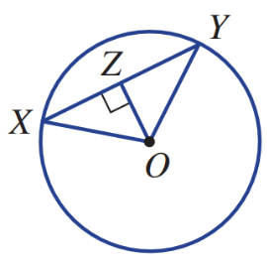  $XZ=4$ cm  $∠XOZ=51°$ | 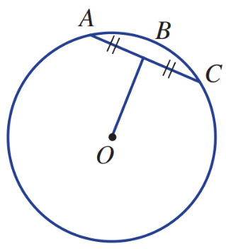  - Given AB = BC, find ∠OBC.  90°
- Given ∠AOB = ∠COD and CD = 3.5 m, find AB.  3.5 m | - Given OE = OF and AB = 9 m , find CD.  9 m
- Given M is the midpoint of AB,  find ∠OMB.  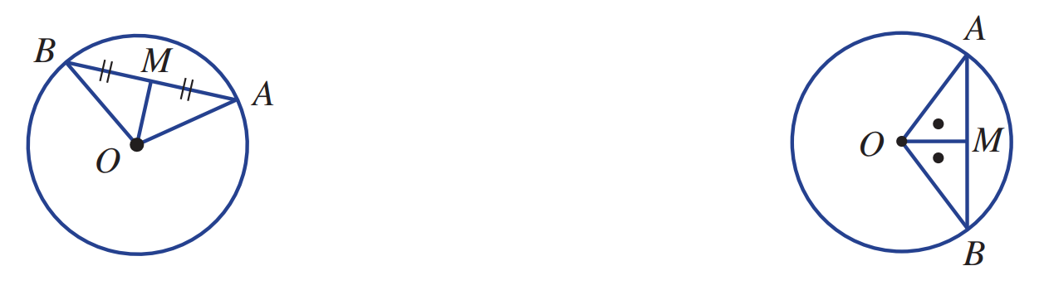  90° | - Given ∠AOM = ∠BOM , find ∠OMB.  90°

Development
- Find the size of each unknown value.
140° | 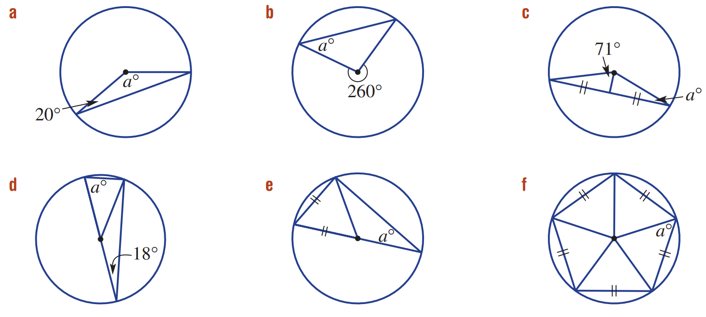  40° | 19°
72° | 30° | 54°
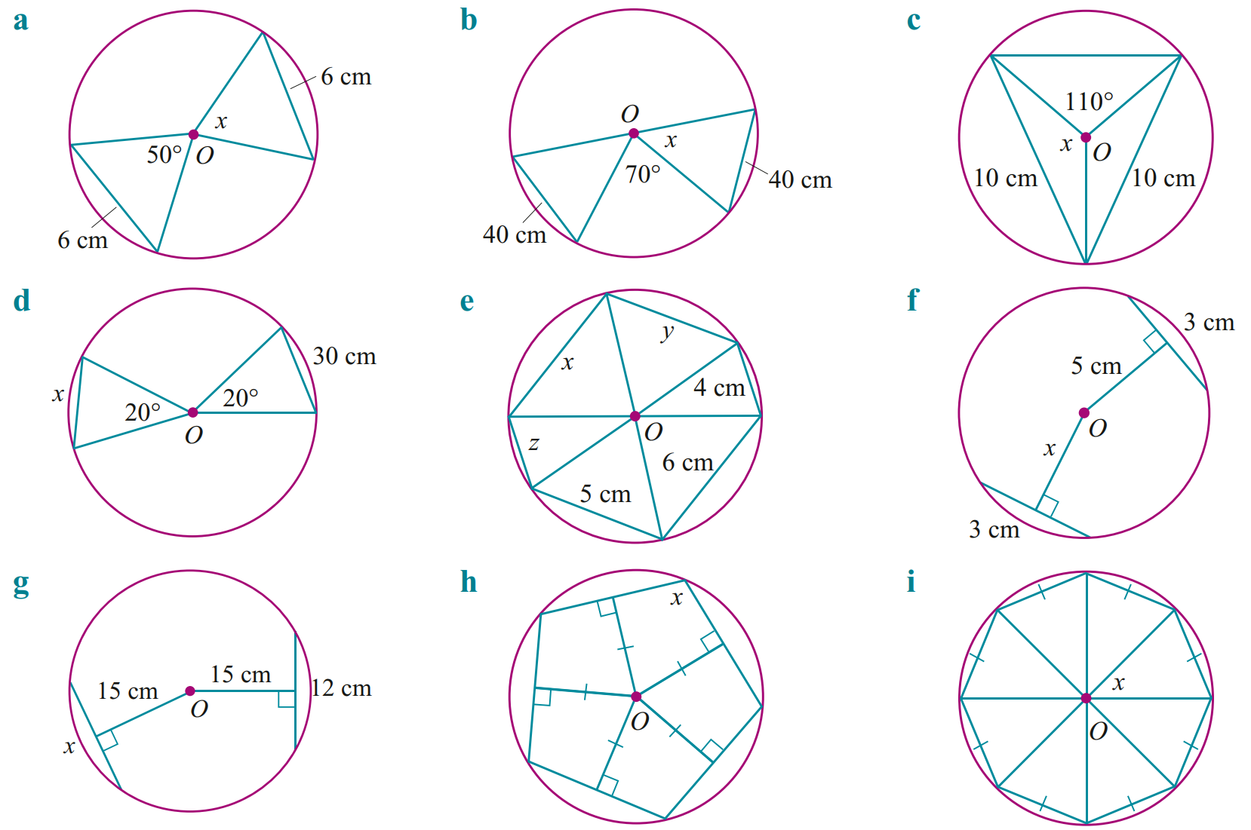  30 cm | $x=6, y=5, z=4$ cm | $x=5$ cm

- Find the length OM. Use Pythagoras’ Theorem.
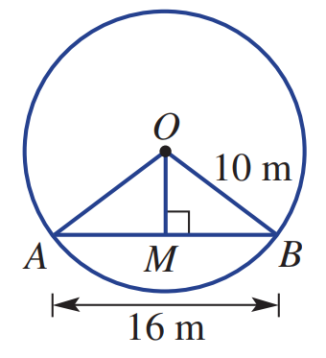

6 m
- In this diagram, radius AD = 5 mm, radius BD = 12 mm and chord CD = 8 mm.
Find the exact length of AB, in surd form.
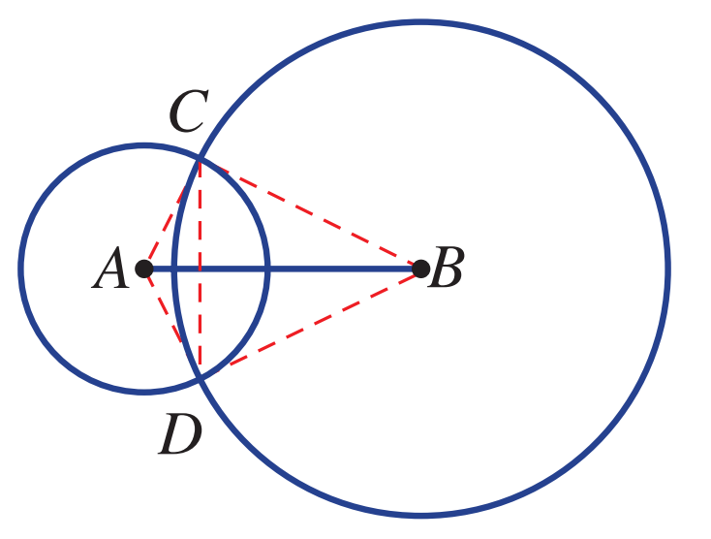

3 + $8\sqrt{2}$ mm
- In the diagrams below, P and Q are the centres of the circles. Find the values of the variables.
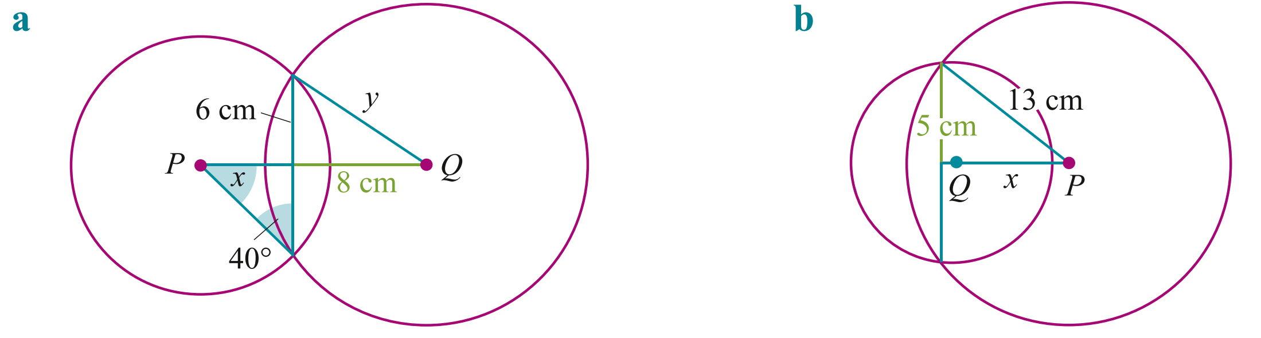  $x=50°, y=10$ cm | $x=12$ cm

Mastery
- Complete the following proofs.
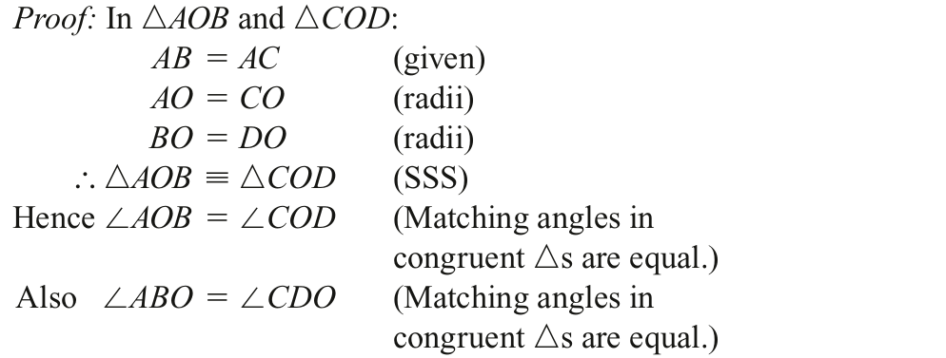
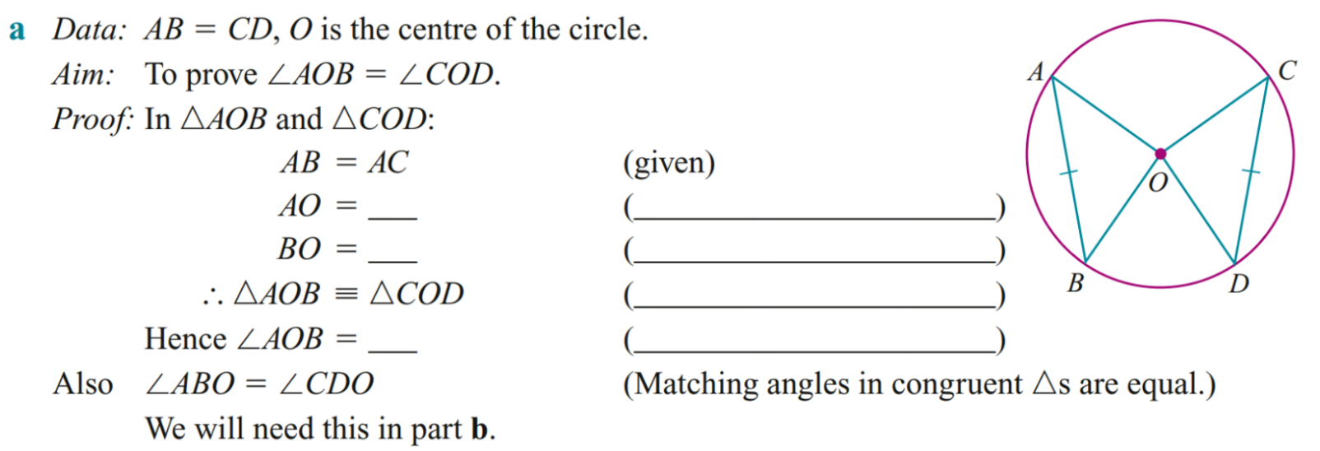

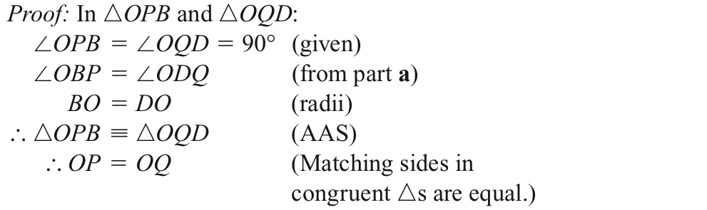
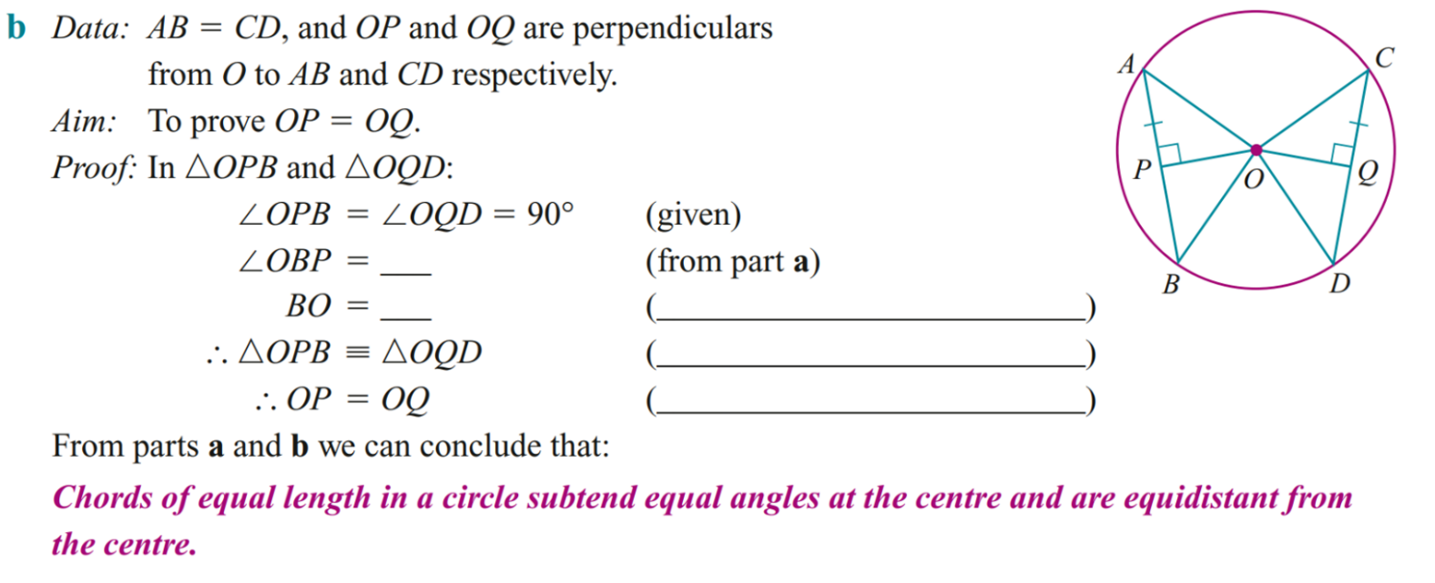

c Use the diagram to prove △OAP ≡ △OBP, hence prove:
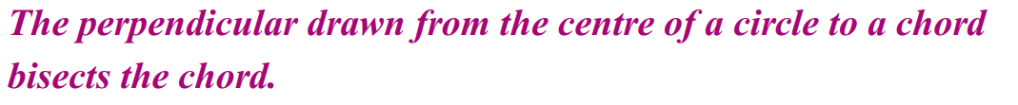

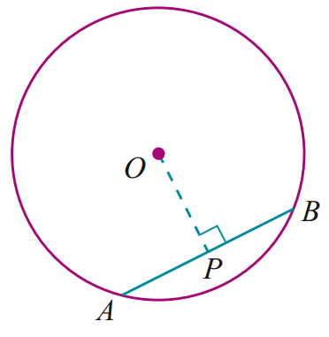

$$∠OPA=∠OPB=90°$$
$OA=OB$(radii of a circle)
$OP$ is common
△OAP ≡ △OBP (RHS)
$∴AP=PB$(corresponding sides of congruent triangles equal)
$∴$ The perpendicular drawn from the centre of a circle to a chord bisects the chord.

- In this circle ∠BAO = ∠CAO. Prove AB = AC. Suggestion: Construct BC.
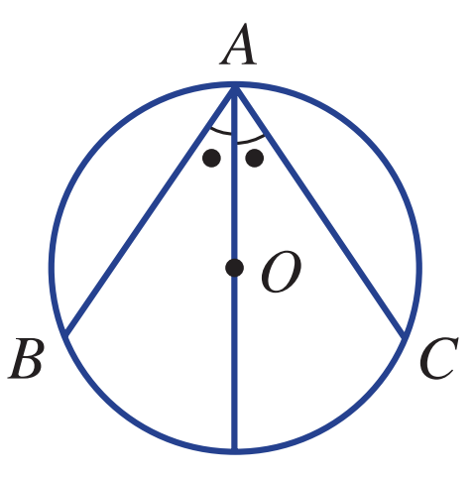

First, prove △OAB ≡ △OAC (AAS), which are isosceles.
So, AB = AC, corresponding sides in congruent triangles.
- In this question we will prove the following theorem. When two circles intersect, the line joining their centres bisects that common chord at right angles.
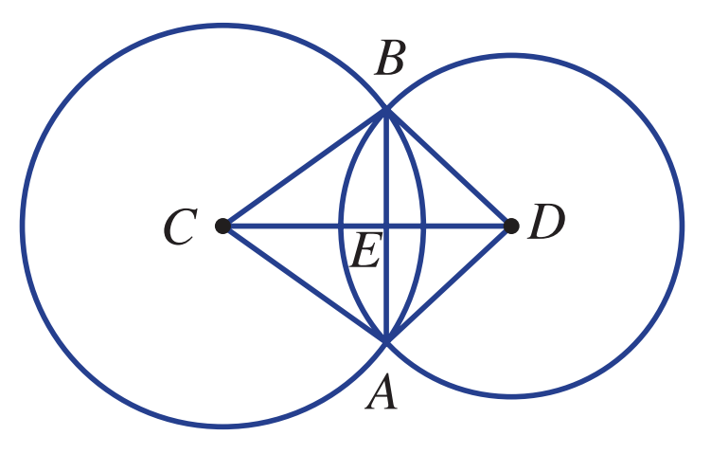
  - Prove △ACD ≡ △BCD.

AD = BD (equal radii),
AC = BC (equal radii),
CD is common.
Therefore, △ACD ≡ △BCD (SSS).
  - Hence, prove △ACE ≡ △BCE.

AC = BC,
∠ACE = ∠BCE (corresponding angles),
CE is common.
Therefore, △ACE ≡ △BCE (SAS).
  - Hence, prove CD ⟂ AB and BE = EA.

∠BEC = ∠CEA = 90°(equal angles on a straight line).
Therefore, CD ⟂ AB and BE = EA (matching sides in congruent triangles).

Angle Properties

- Angle Properties
The angle at the centre is twice the angle at the circumference when standing on the same arc. | The angle in a semicircle is $90°$  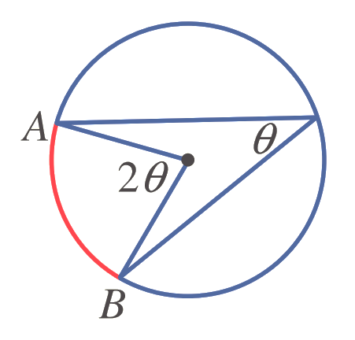  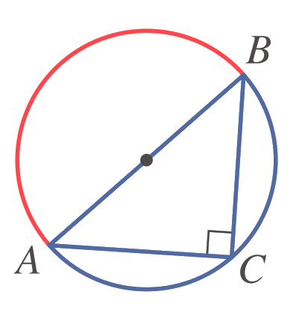 | 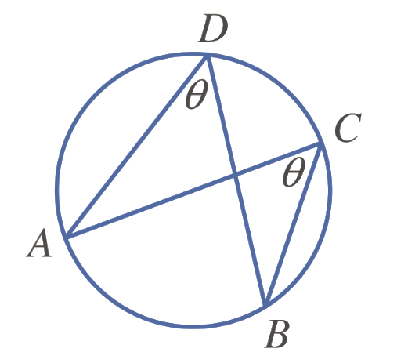  Angles at the circumference standing on the same arc are equal.

- Example Apply angle properties to find unknown values
$x=70°$ (Angle at centre twice angle at circumference when on the same arc.) | 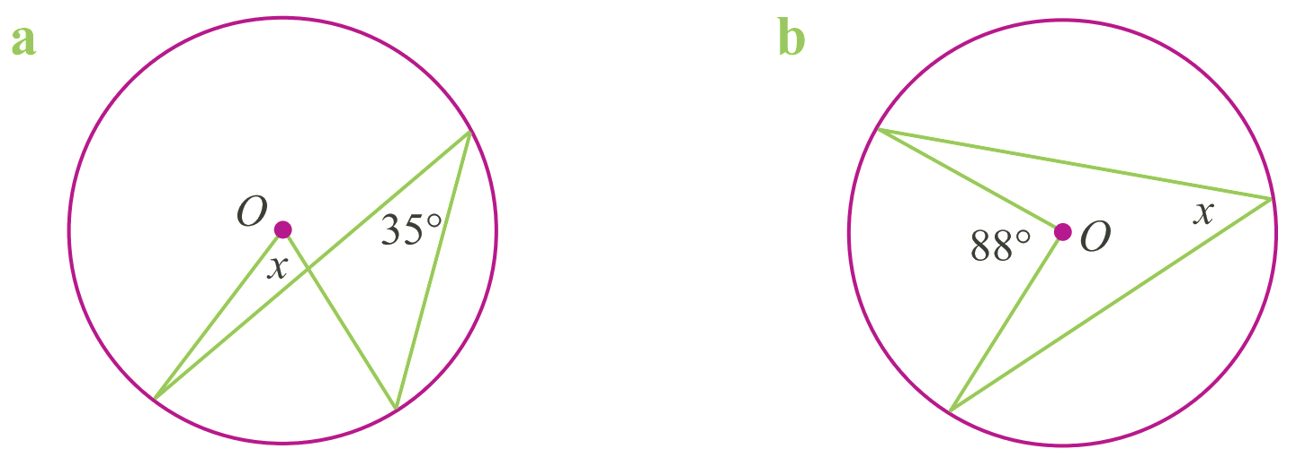  $x=44°$ (angle at centre is twice angle at circumference when on the same arc.)

- Guided Practice
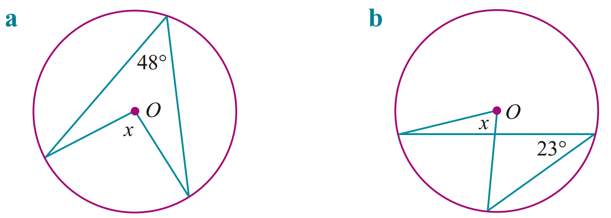  $$96$$ | $$46$$
$$55$$ | 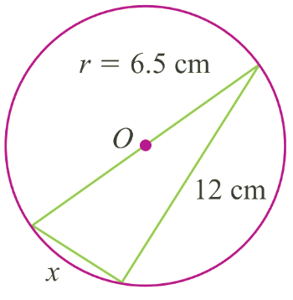  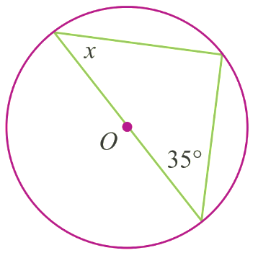  $5$ cm

Foundation
- For this circle, O is the centre.
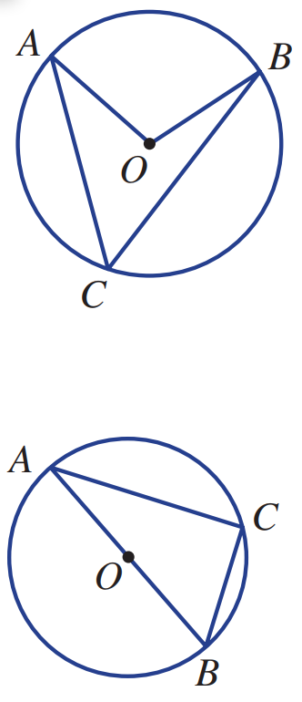
  - Name the angle at the centre of the circle subtended by AB.
∠AOB
  - Name the angle at the circumference subtended by AB.
∠ACB
  - If ∠ACB = 40°, find ∠AOB.
80°
  - If ∠AOB = 122°, find ∠ACB.
61°

- For this circle, AB is a diameter.
  - What is the size of ∠AOB?
180°
  - What is the size of ∠ACB?
90°
  - If ∠CAB = 30°, find ∠ABC.
60°
  - If ∠ABC = 83°, find ∠CAB.
7°

- For this circle, answer the following.
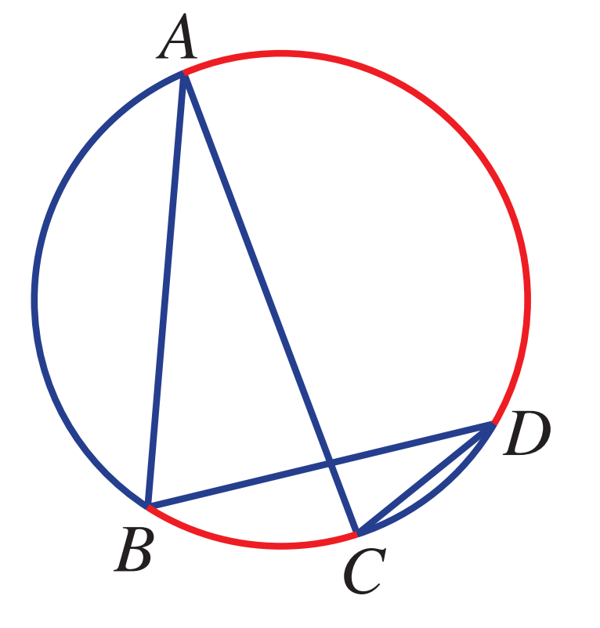
  - Name two angles subtended by arc AD.
∠ABD and ∠ACD
  - State the size of ∠ACD if ∠ABD = 85°.
85°
  - Name two angles subtended by arc BC.
∠BAC and ∠BDC
  - State the size of ∠BAC if ∠BDC = 17°.
17°

- Find the value of $x$ in these circles.
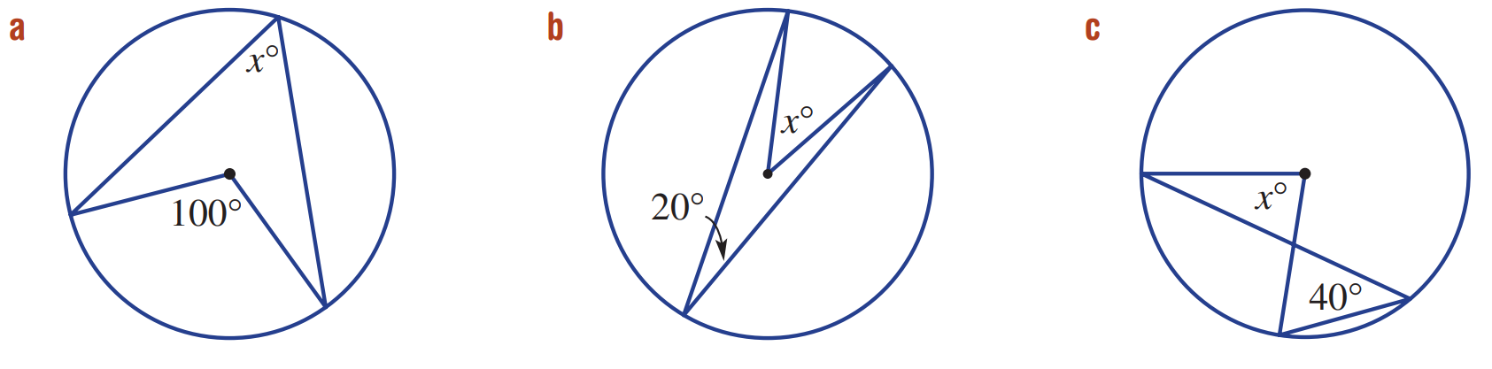  50° | 40° | 80°
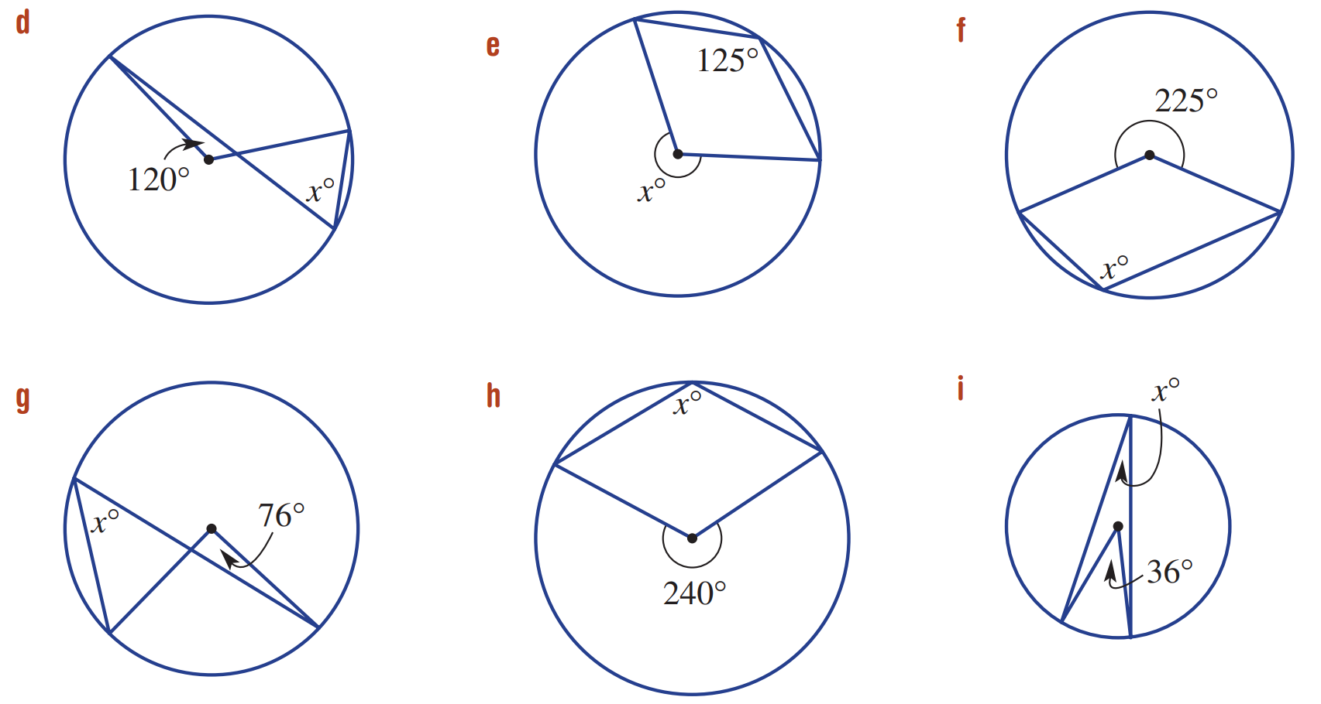  60° | 250° | 112.5°
38° | 120° | 18°
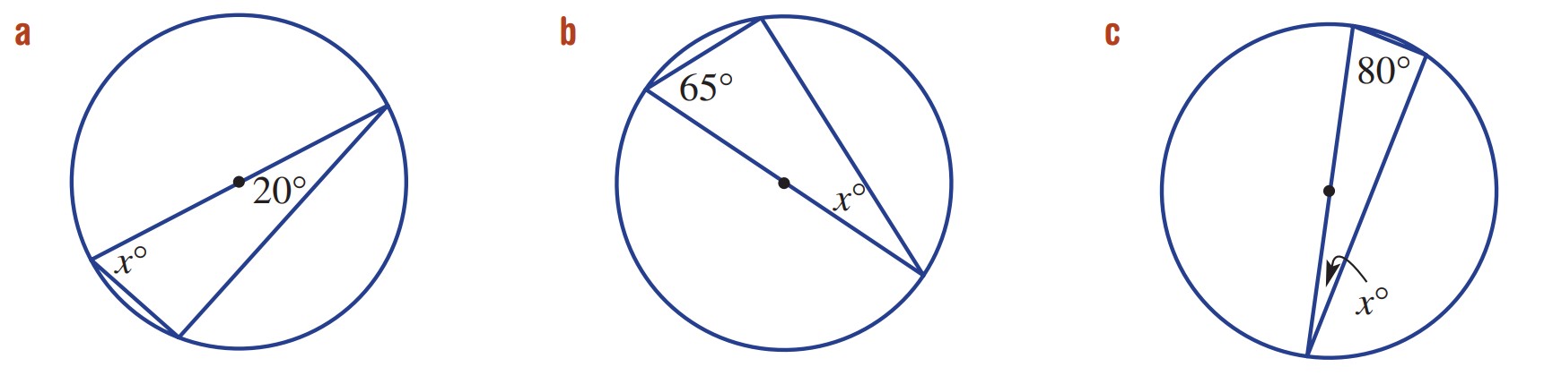  70° | 25° | 10°

- Find the value of $x$.
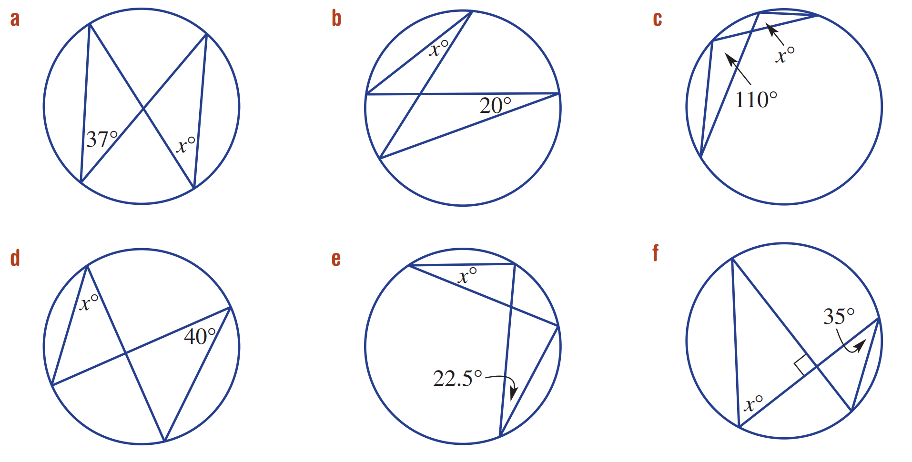  37° | 20° | 110°
40° | 22.5° | 55°

- Find the size of both ∠ABC and ∠ABD.
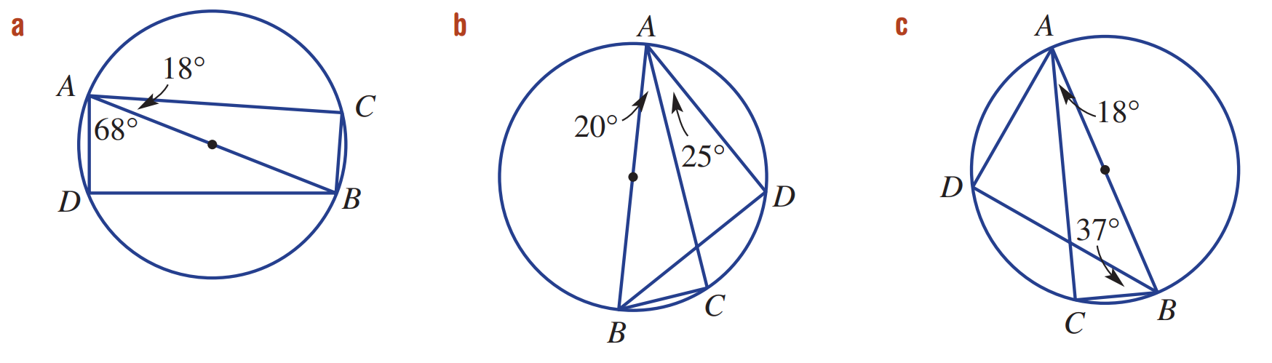  ∠ABC = 72°, ∠ABD = 22° | ∠ABC = 70°, ∠ABD = 45° | ∠ABC = 72°, ∠ABD = 35°

Development

- Find ∠ADC and ∠ABC  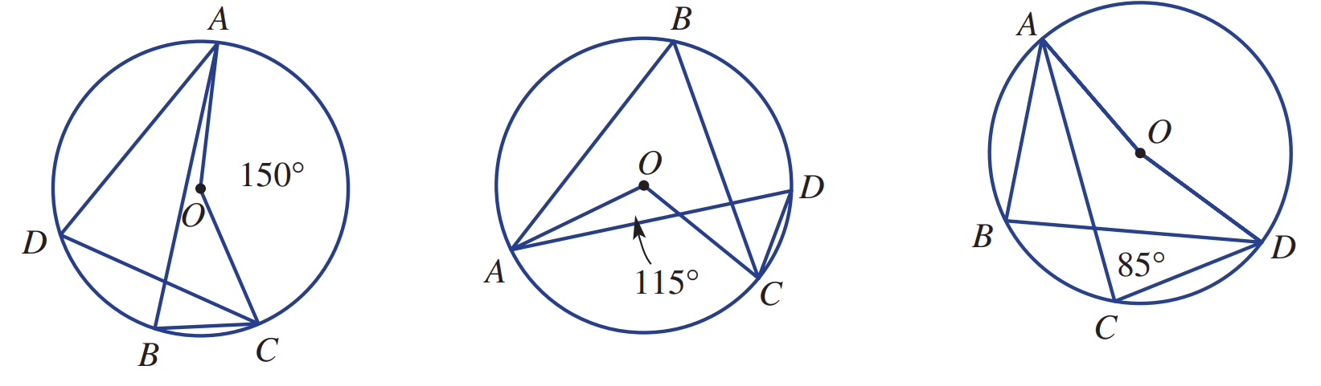  ∠ADC = 75°, ∠ABC = 75° | - Find ∠ABC and ∠ADC  ∠ABC = 57.5°, ∠ADC = 57.5° | - Find ∠AOD and ∠ABD  ∠AOD = 170°, ∠ABD = 85°

- Find ∠ABC.
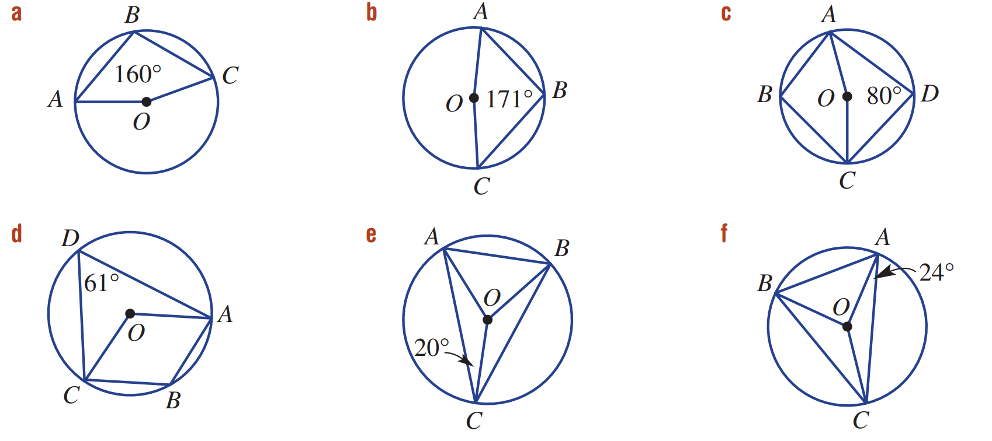  100° | 94.5° | 100°
119° | 70° | 66°

- Find ∠OAB.
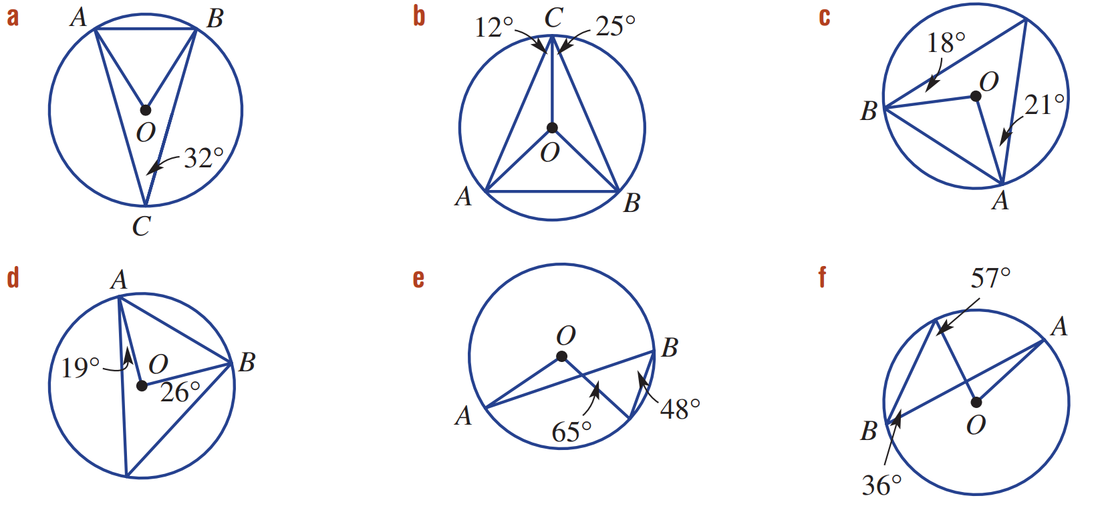  58° | 53° | 51°
45° | 19° | 21°

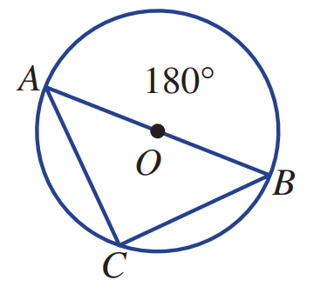
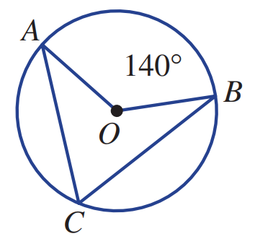

  - For the first circle shown, find ∠ACB
70°
  - For the second circle shown, find ∠ACB
90°
  - Explain why “The angle in a semicircle is 90°” is a special case of “The angle at the centre of a circle is twice the angle at the circumference when standing on the same arc.”

The second circle is the specific case of the first circle when the angle at the centre is 180°.

Mastery
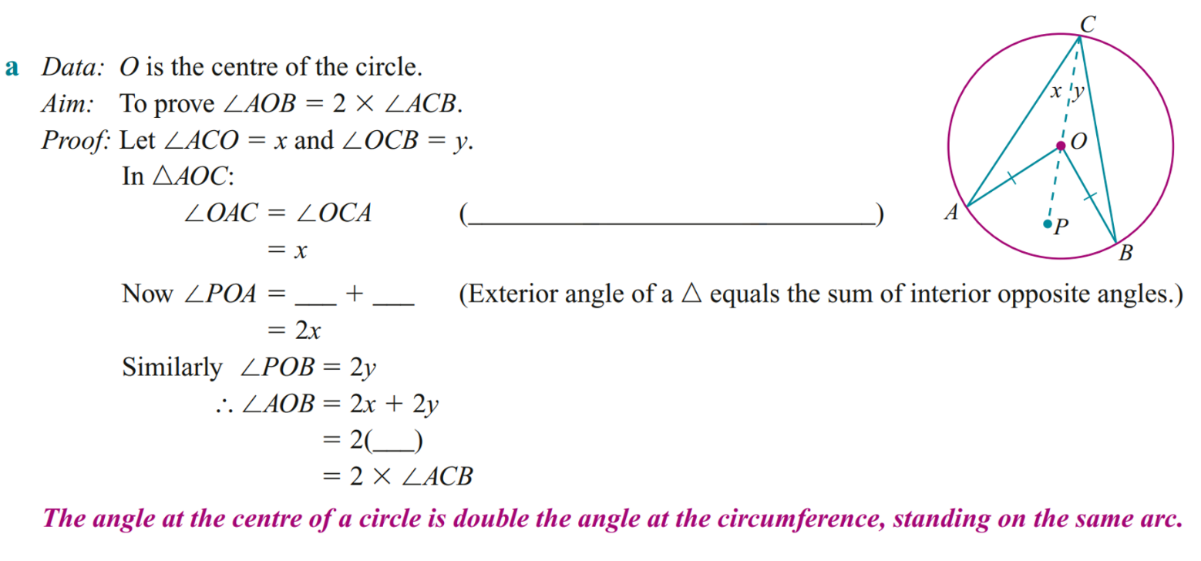
- Complete the following proofs
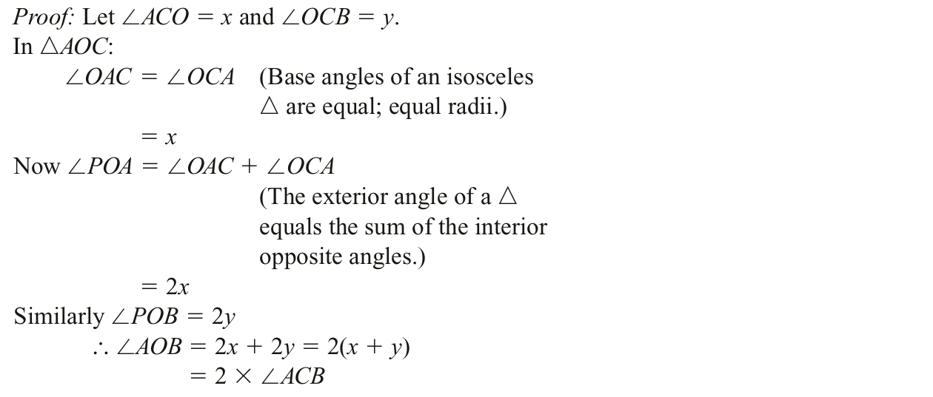

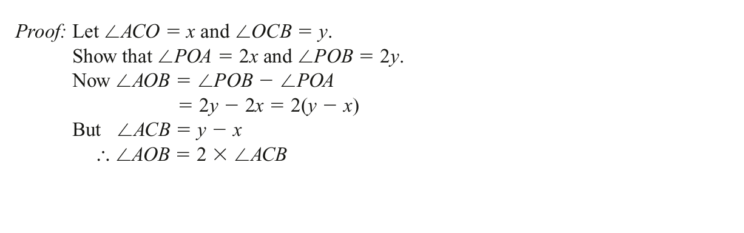
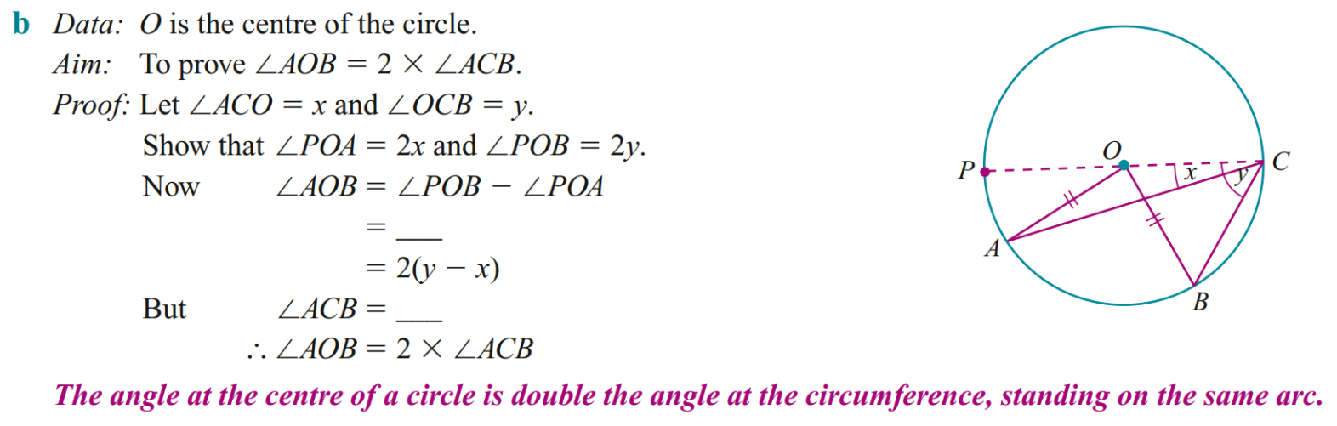

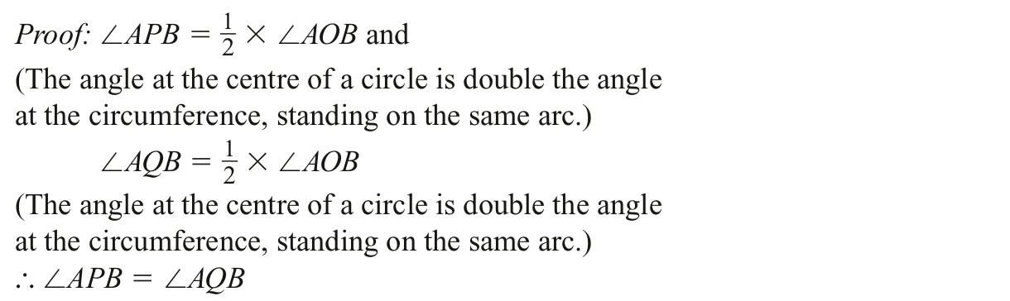
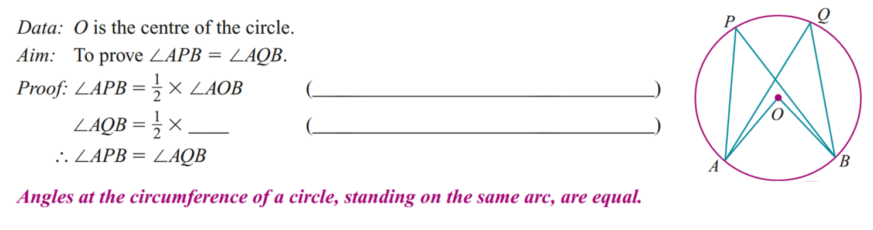
c

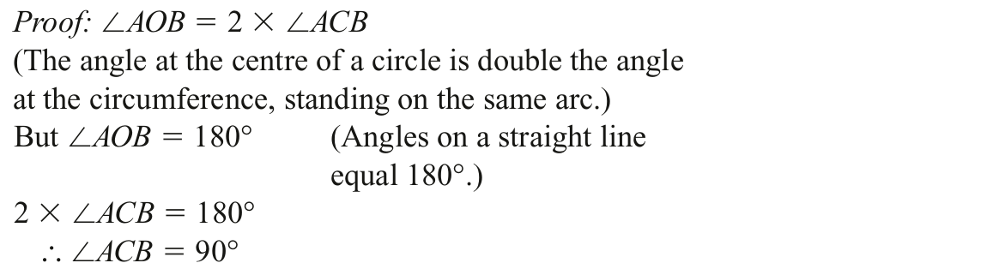
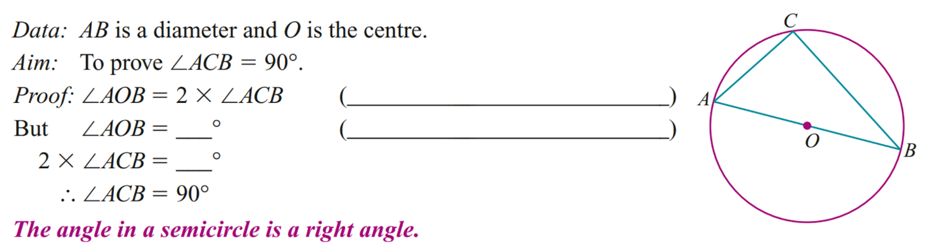
d

Cyclic Quadrilaterals

- Cyclic Quadrilaterals
- A cyclic quadrilateral is a four-sided shape whose vertices all lie on a circle.

The opposite angles of cyclic quadrilaterals sum to 180° (supplementary).  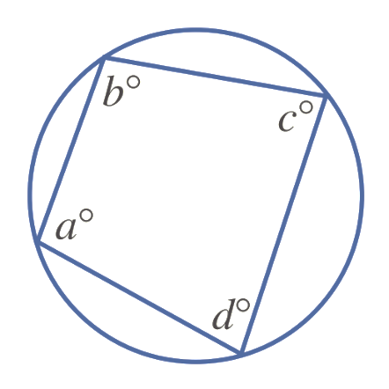  $a+c=180°$  $b+d=180°$ | 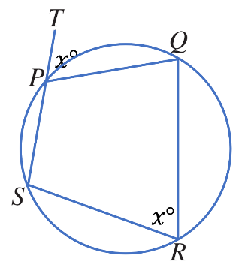  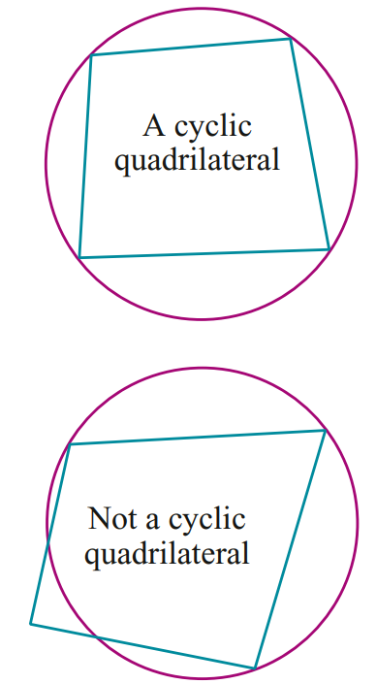  Exterior angles in cyclic quadrilaterals equal the opposite interior angle

- Example Apply properties of cyclic quadrilaterals to find unknown values
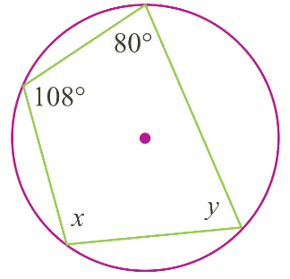  $x+80°=180°$  $x=100°$  $108°+y=180°$  $y=72°$ | 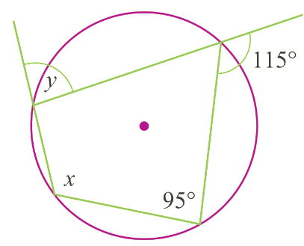  $x=115°$  $y=95°$

- Guided Practice
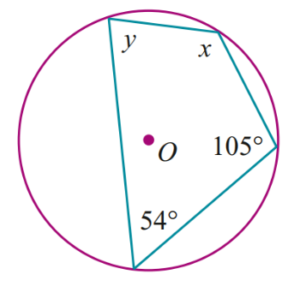  $$x=126, y=75$$ | 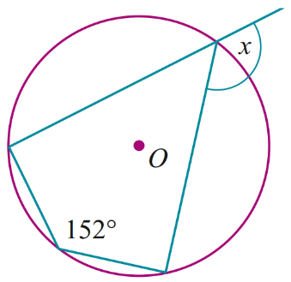  $$x=152$$

Foundation
- Opposite angles in a cyclic quadrilateral are supplementary.
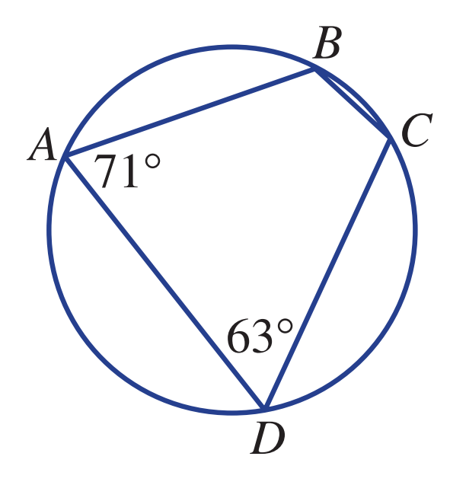
  - What does it mean when we say two angles are supplementary?
Supplementary angles sum to 180°.
  - Find ∠ABC.
117°
  - Find ∠BCD.
109°
  - Check that ∠ABC + ∠BCD + ∠CDA + ∠DAB = 360°.
117° + 109° + 63° + 71° = 360

- Find the value of the pronumerals in these circles.
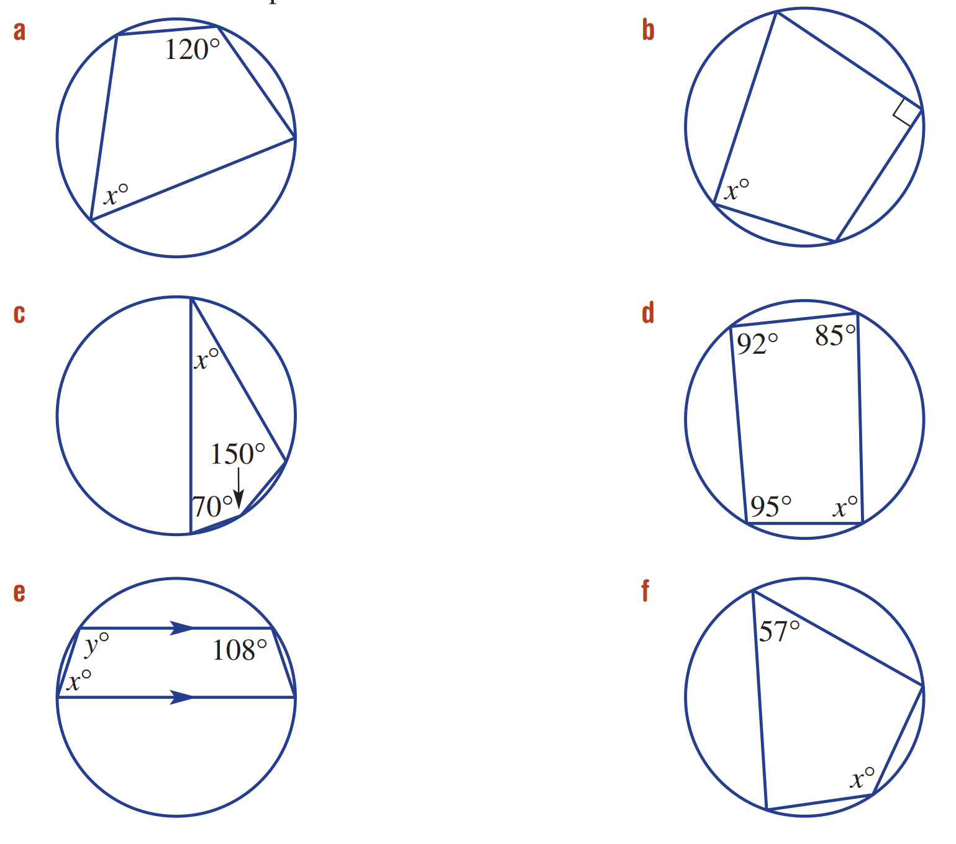  60° | 90° | 30°
88° | $$x=72°, y=108°$$ | 123°
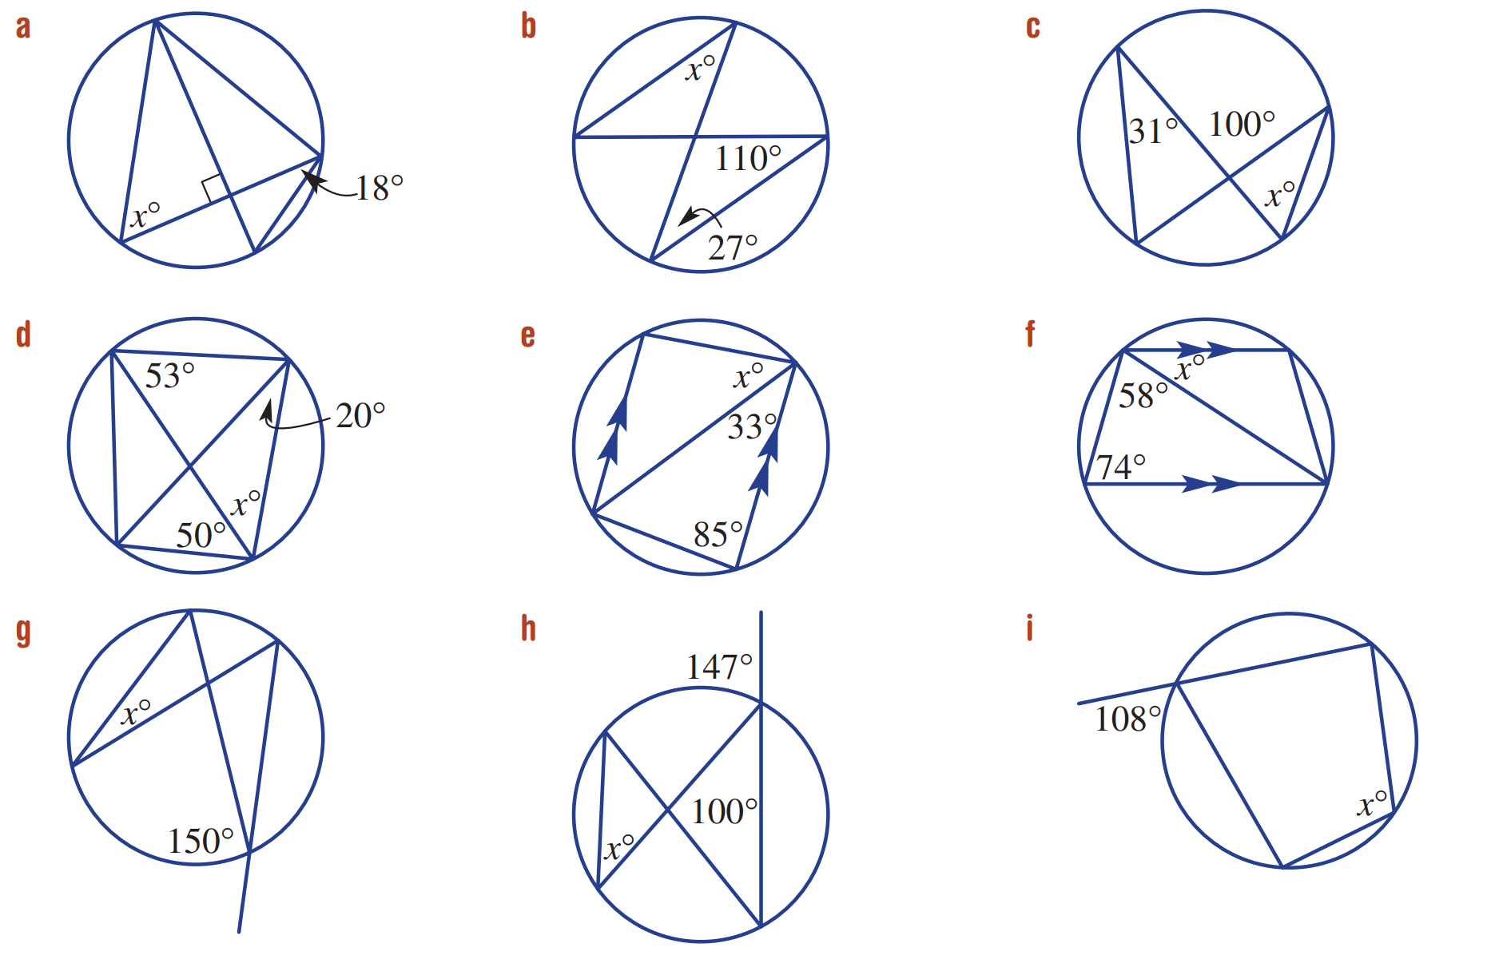  72 | 43 | 69

Development
57 | 52 | 48
30 | 47 | 108
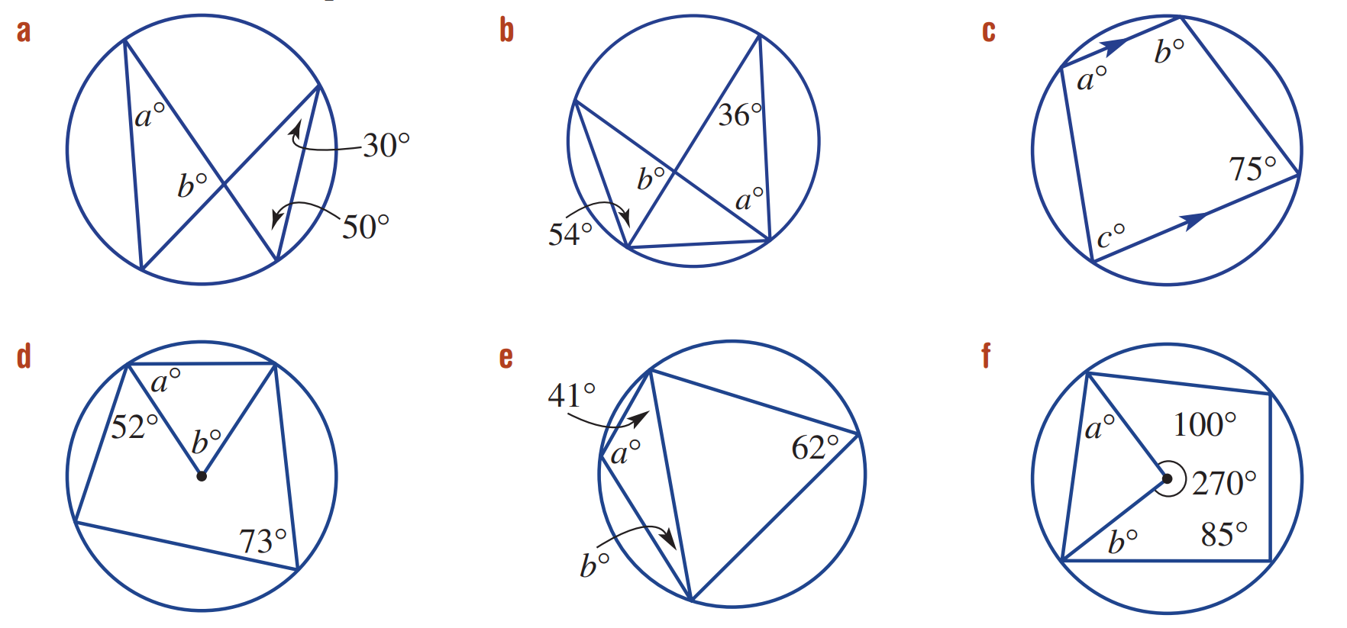  a = 30, b = 100 | a = 54, b = 90 | a = 105, b = 105, c = 75
a = 55, b = 70 | a = 118, b = 21 | a = 45, b = 35
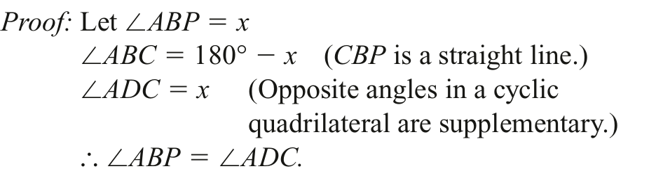
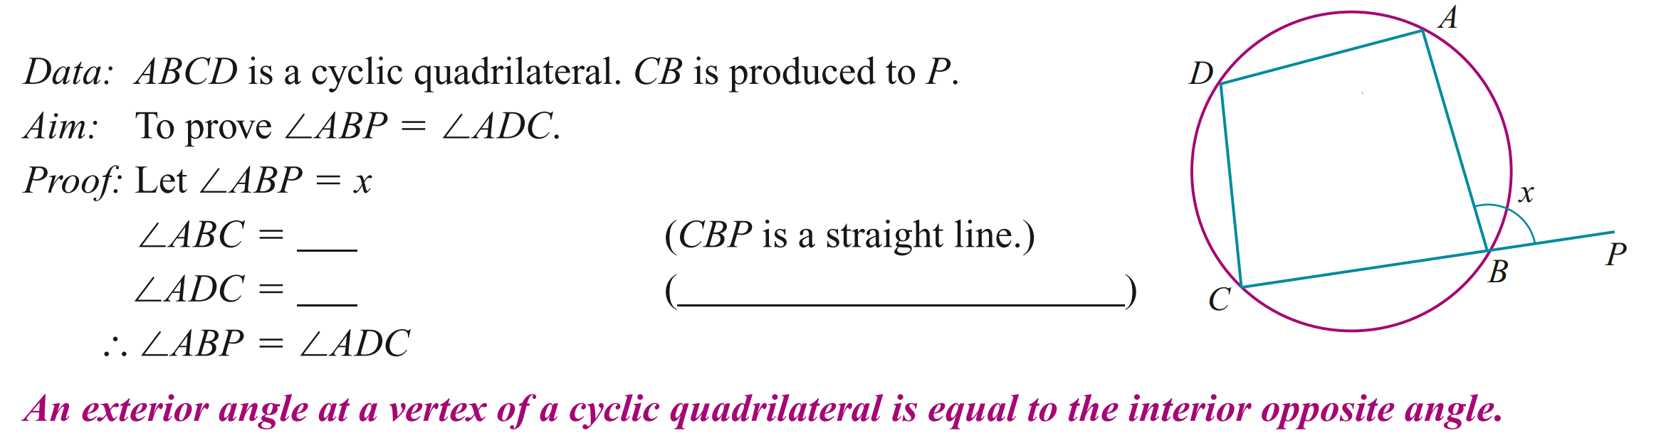

Tangent and Secant Properties

- Tangent and Secant Properties
Angle between tangent and radius = 90° | Tangents from an external point are equal in length. | Alternate segment theorem The angle between a tangent and a chord at the point of contact is equal to the angle in the alternate segment.  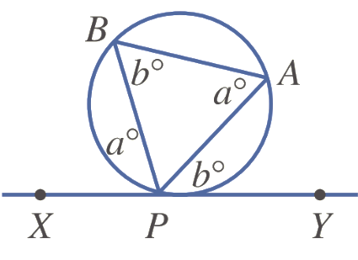  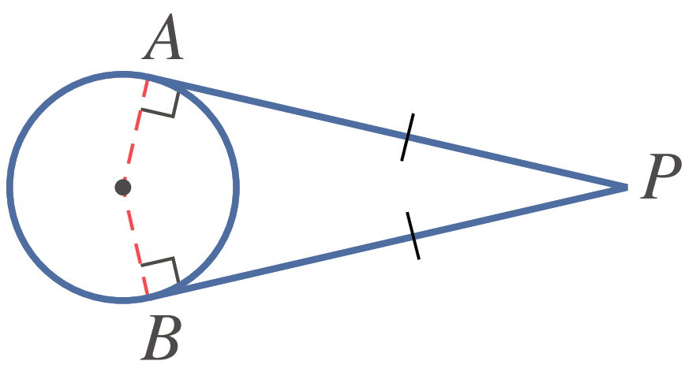  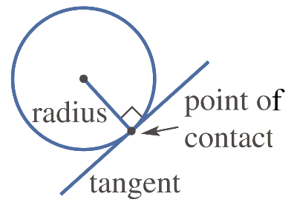

- Example Apply tangent and secant properties to find unknown values
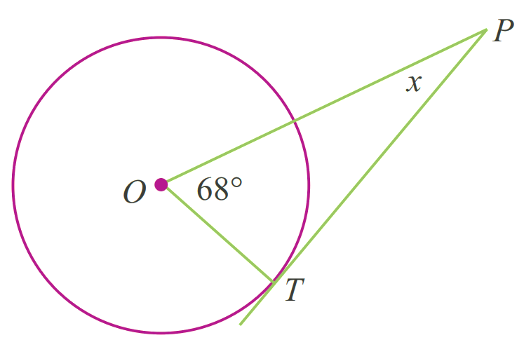  $∠OTP=90°$  (A tangent is perpendicular to the radius at the point of contact)  $x+90°+68°=180°$  $x=22°$ | $x=12$ cm  (Tangents drawn to a circle from an external point are equal.)  $$y=\frac{180-40}{2}=70°$$  (Base angles of isosceles triangle equal) | 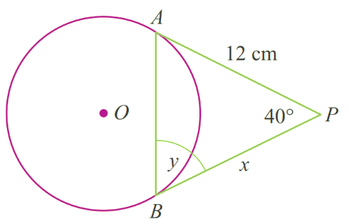  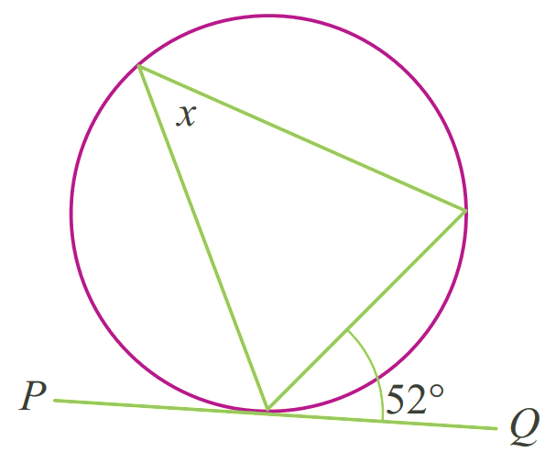  $x=52°$  (Alternate segment theorem)

- Guided Practice
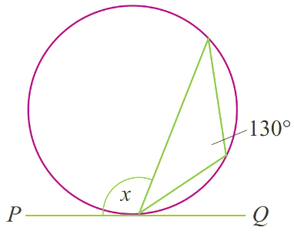  $$130°$$ | 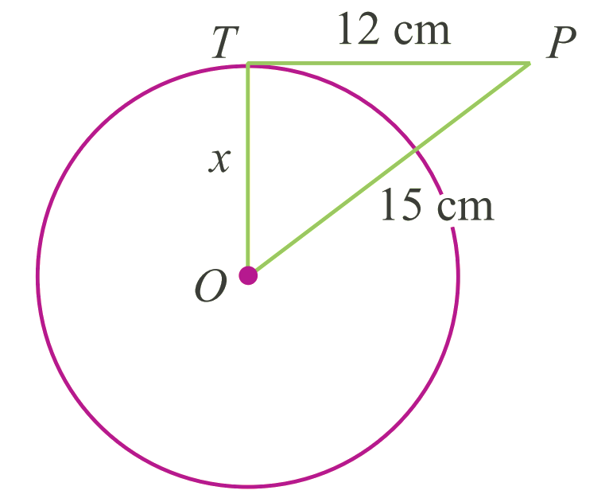  $9$ cm | 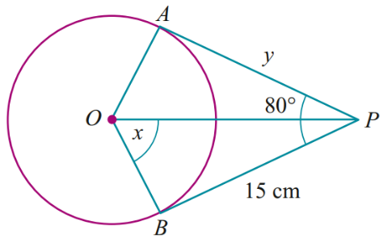  $$x=50°, y=15°$$

Foundation

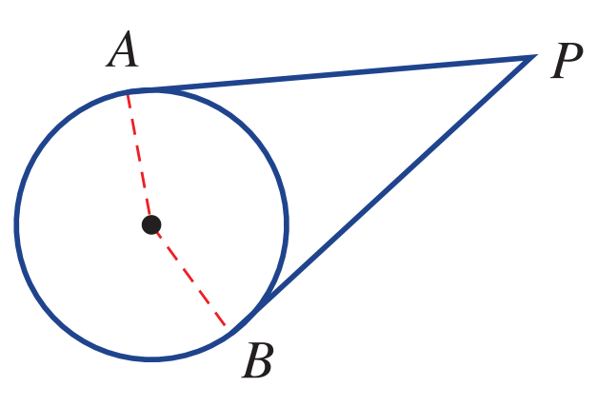
  - How many times does a tangent intersect a circle?
once
  - At the point of contact, what angle does the tangent
make with the radius?
90°
  - If AP is 5 cm, what is the length of BP in this diagram?
Also 5 cm
- For this diagram name the angle that is:
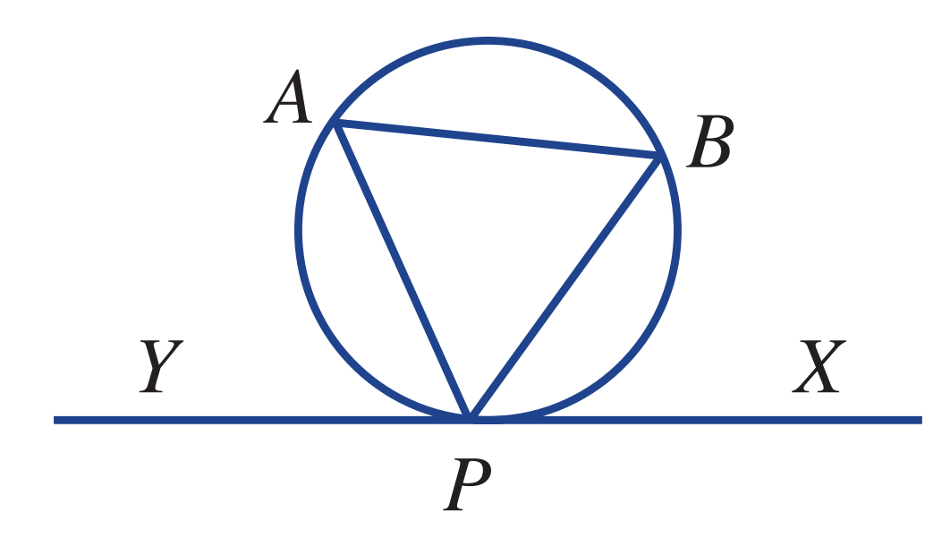
  - equal to ∠BPX
∠BAP
  - equal to ∠BAP
∠BPX
  - equal to ∠APY
∠ABP
  - equal to ∠ABP
∠APY
- Find the value of $a$ in these diagrams that include tangents.
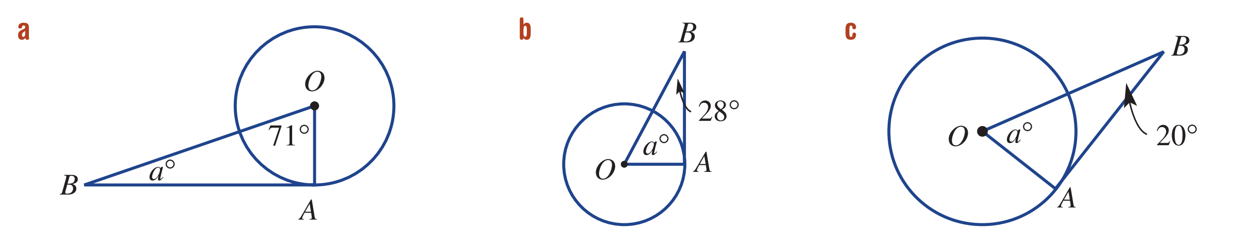  19 | 62 | 70
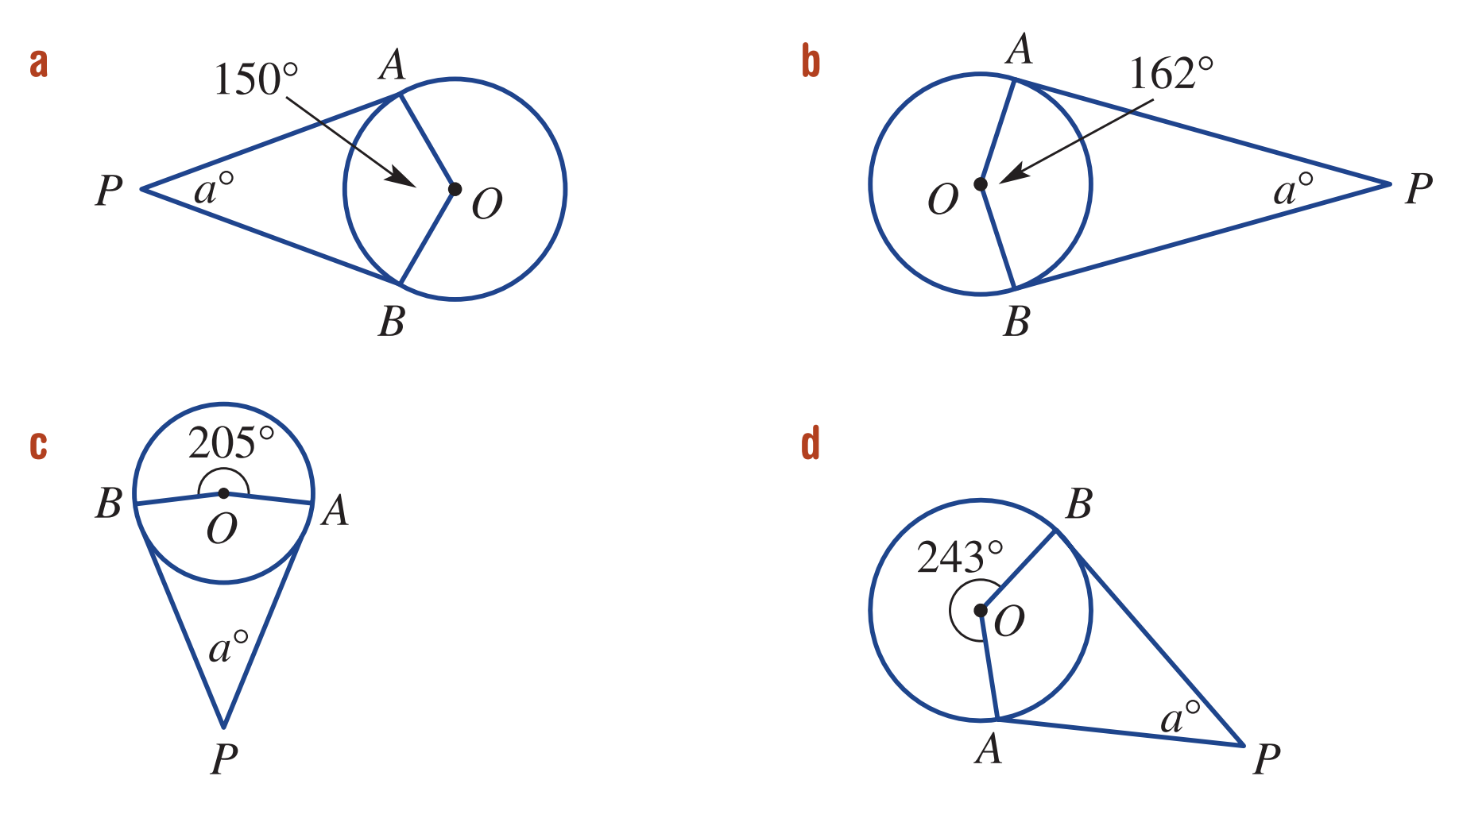  30 | 18 | 25

- In this diagram, XY is a tangent to the circle. Find:
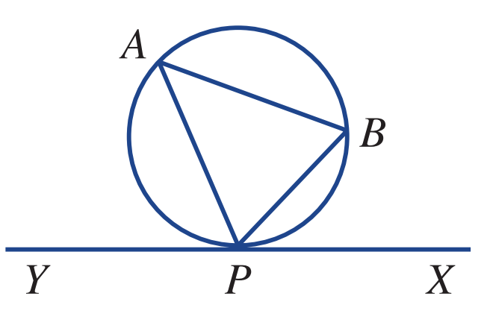
  - ∠PAB if ∠BPX = 50
50°
  - ∠APY if ∠ABP = 59°
59°

Development
- Find the value of a, b and c in these diagrams.
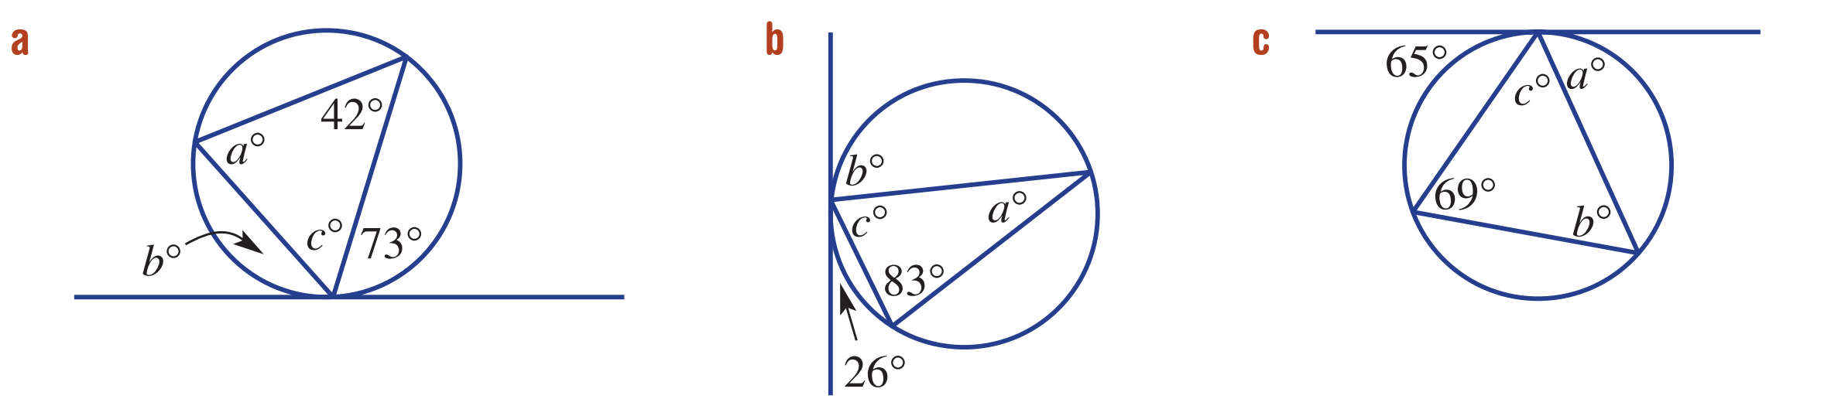  a=73, b=42, c=65 | a=26, b=83, c=71 | a=69, b=65, c=46

- Find the length of AP
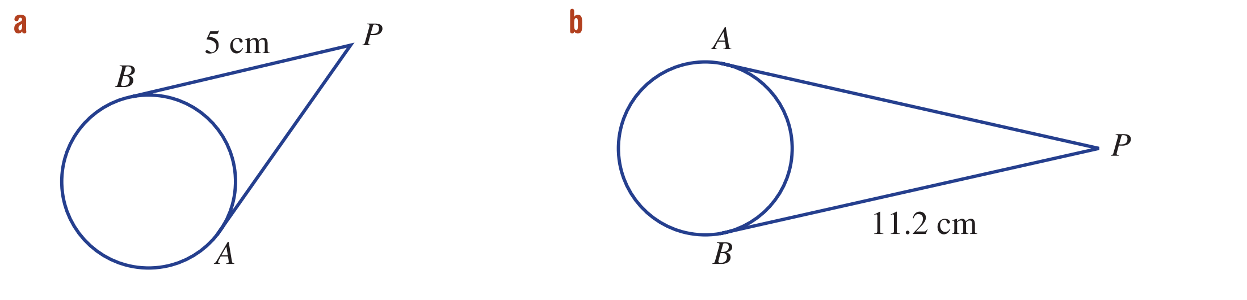  5 cm | 11.2 cm

- Find the value of a
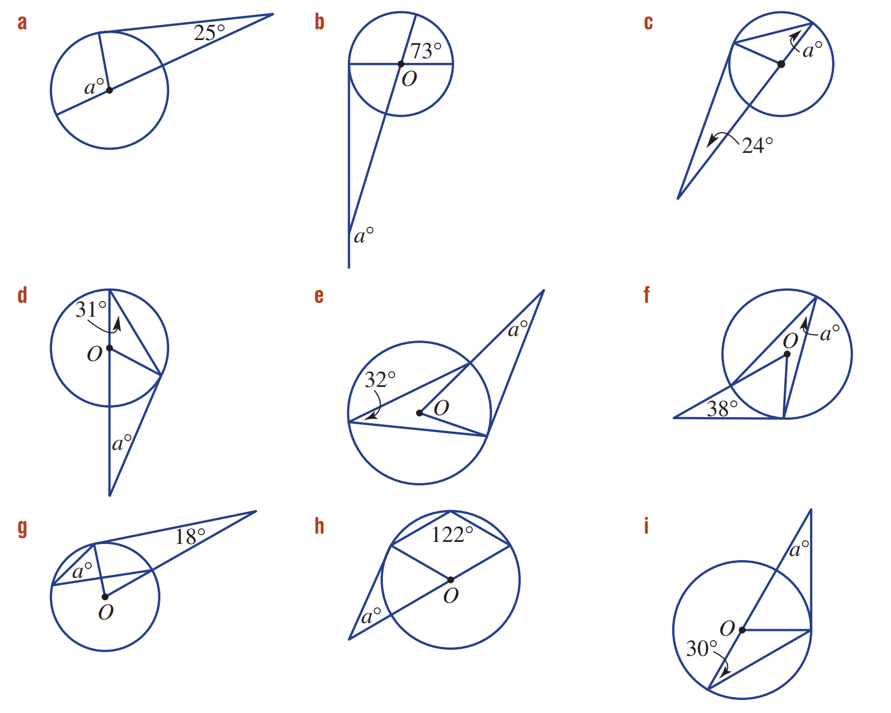  115 | 163 | 33
28 | 26 | 26
36 | 26 | 30
- Find the value of $a$.
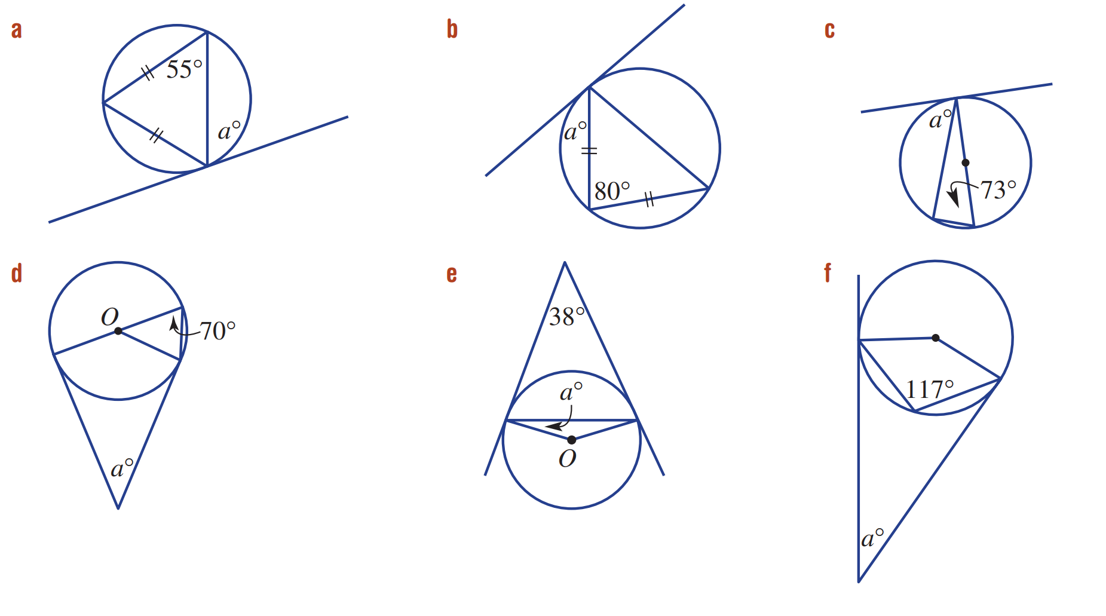  70 | 50 | 73
40 | 19 | 54

- PT and PQ are the tangents from P to a circle with centre O.
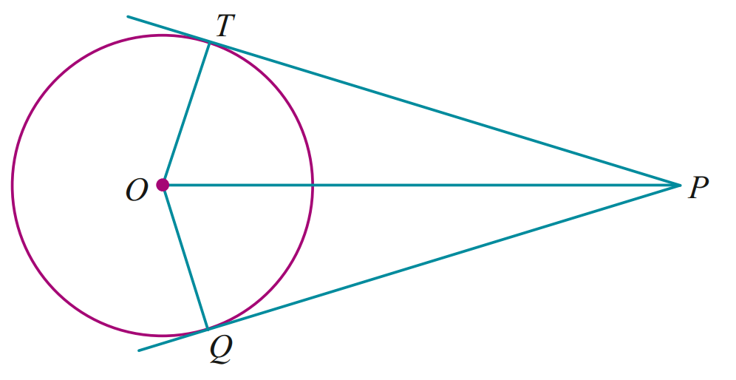
  - Prove △PTO ≡ △PQO.
$∠OTP=∠OQT=90°$ (tangents meet radii at 90°)
$OT=OQ$ (radii)
$OP$ is common
$△PTO ≡ △PQO$ (RHS)

  - Hence prove PT = PQ.
$PT=PQ$ (corresponding sides of congruent triangles equal)
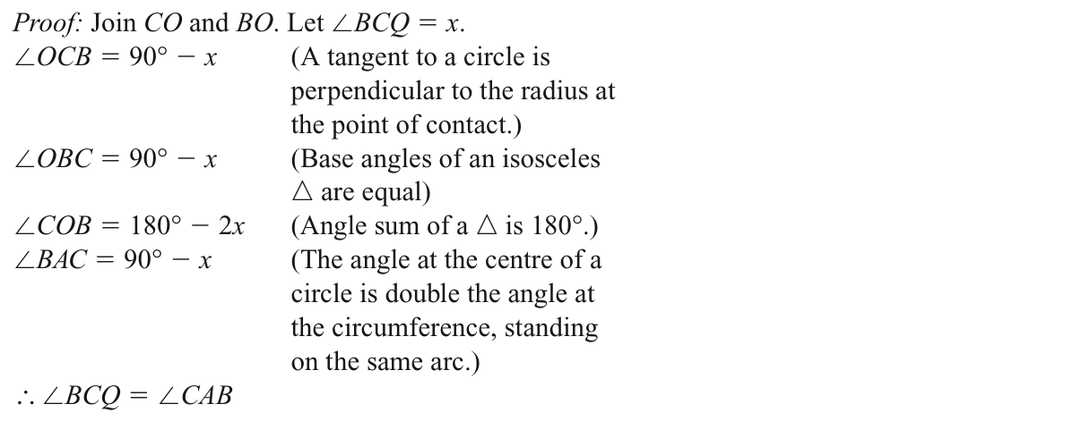
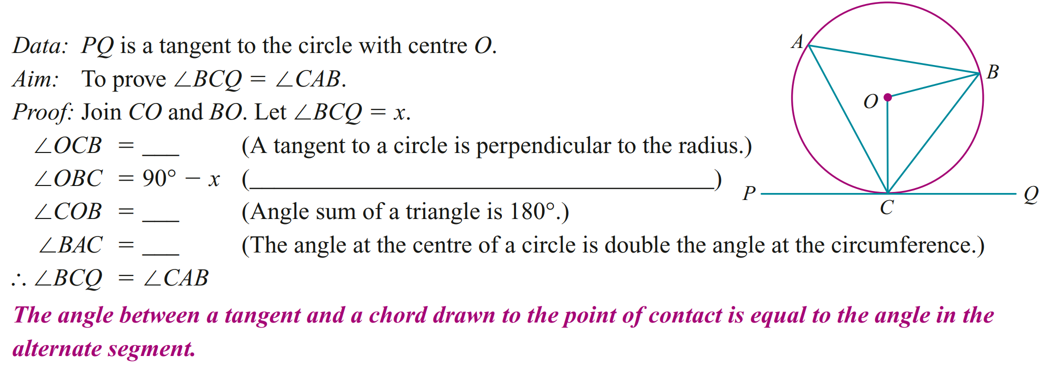

Further Tangent and Secant Properties

- Further Tangent and Secant Properties
The products of the intercepts of two intersecting chords are equal.  $$ac=bd$$ | The products of the intercepts of 2 intersecting secants to a circle from an external point are equal.  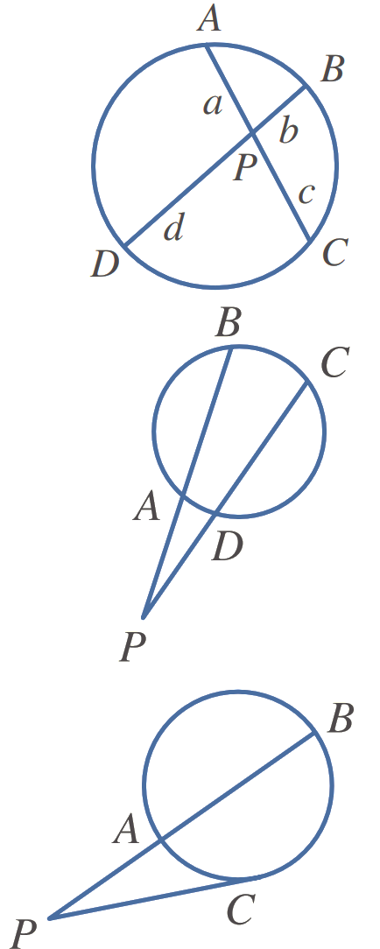  $$AP×BP=DP×CP$$ | The square of a tangent to a circle from an external point equals the product of the intercepts of any secants from the point.  $$CP^{2}=AP×BP$$

- Example Apply tangent and secant properties to find unknown values
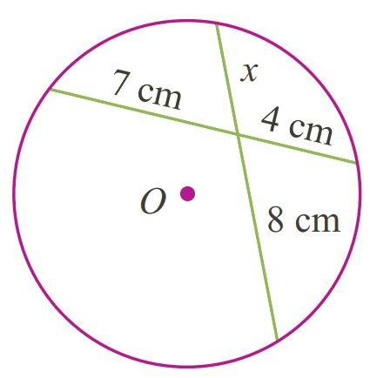  $7×4=8x$  $28=8x$  $$\frac{7}{2}=x$$ | 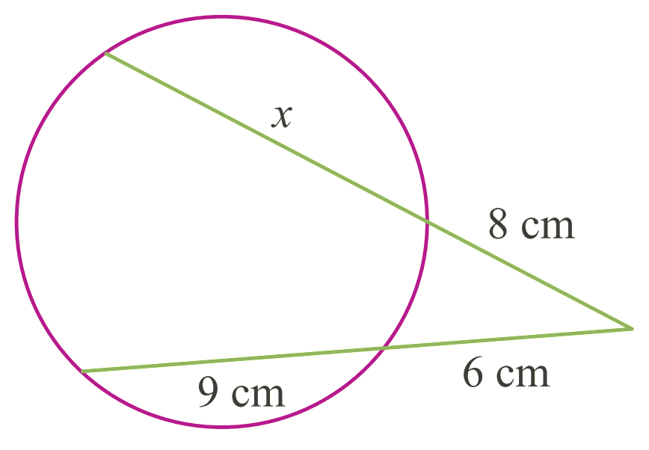  $8\left(x+8\right)=6(6+9)$  $8x+64=90$  $8x=26$  $x=3.25$ | 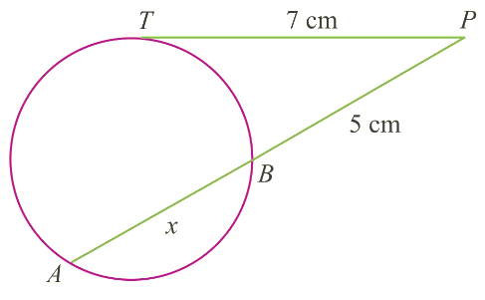  $7^{2}=5\left(5+x\right)$  $49=25+5x$  $24=5x$  $4.8=x$

- Guided Practice
4 cm | - $TA=8 cm, TB=2 cm$Find $TP$  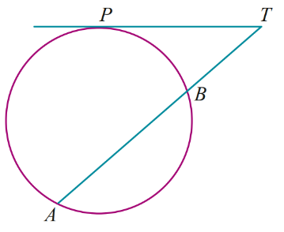  4 cm | 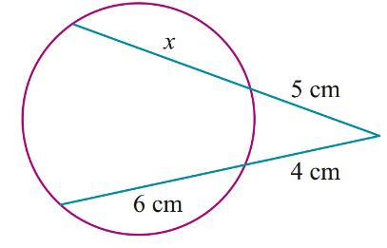  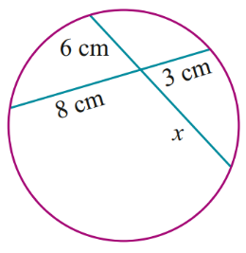  3 cm

Foundation
- Complete the rules for each diagram.
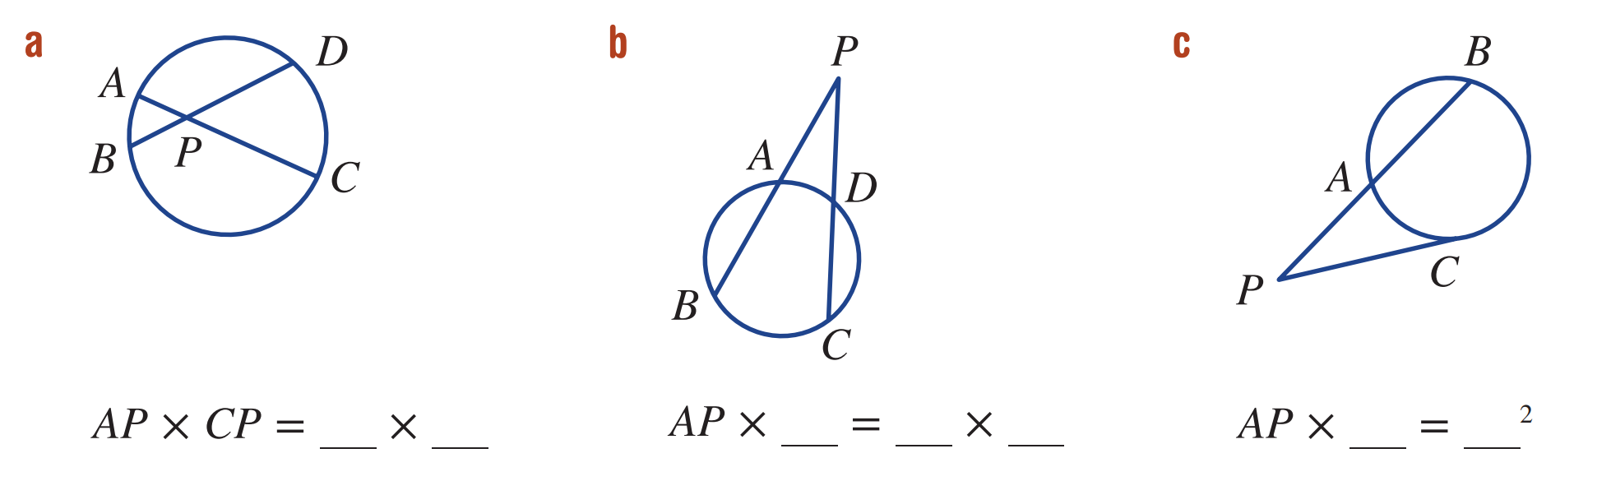  AP×CP=BP×DP | AP×BP=DP×CP | AP×BP=CP²

- Find the length of $x$ in each figure.
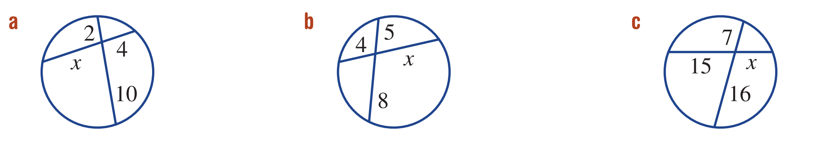  5 | 10 | $$\frac{112}{15}$$
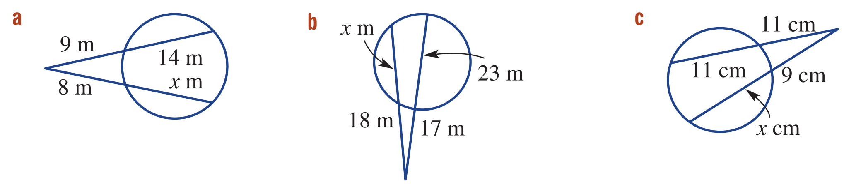  $$\frac{143}{8}$$ | $$\frac{178}{9}$$ | $$\frac{161}{9}$$
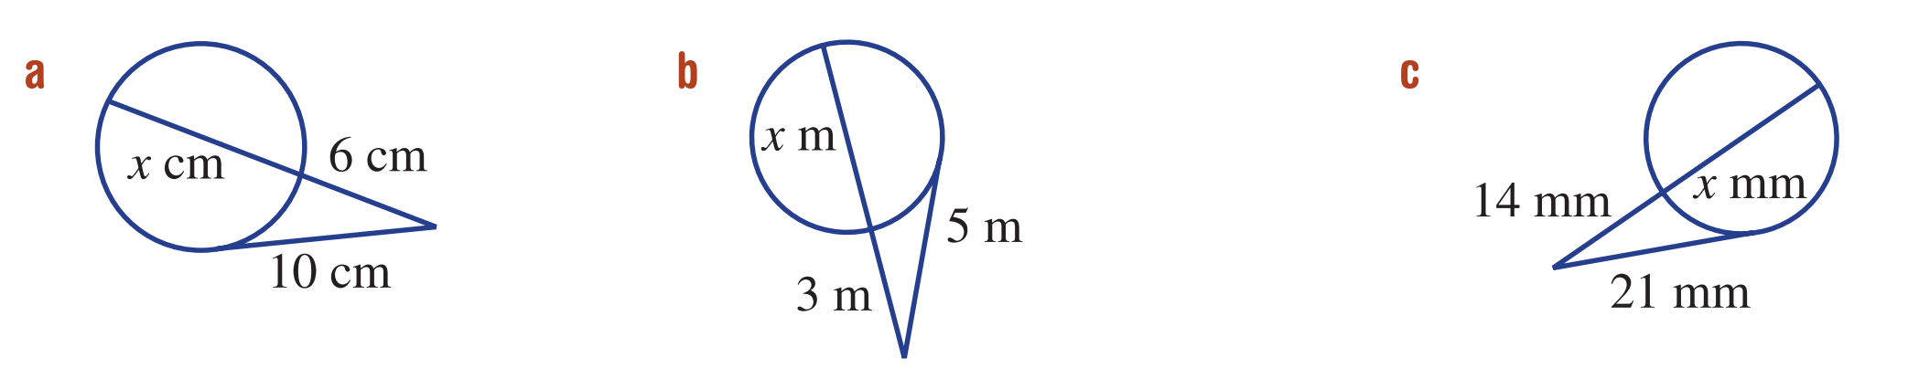  $$\frac{32}{3}$$ | $$\frac{16}{3}$$ | $$\frac{35}{2}$$
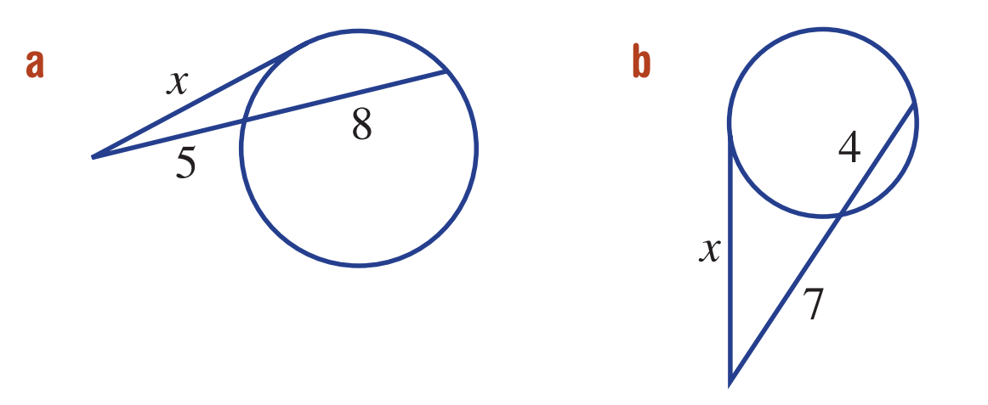  $$\sqrt{65}$$ | $$\sqrt{77}$$

Development
- Find the value of $x$.
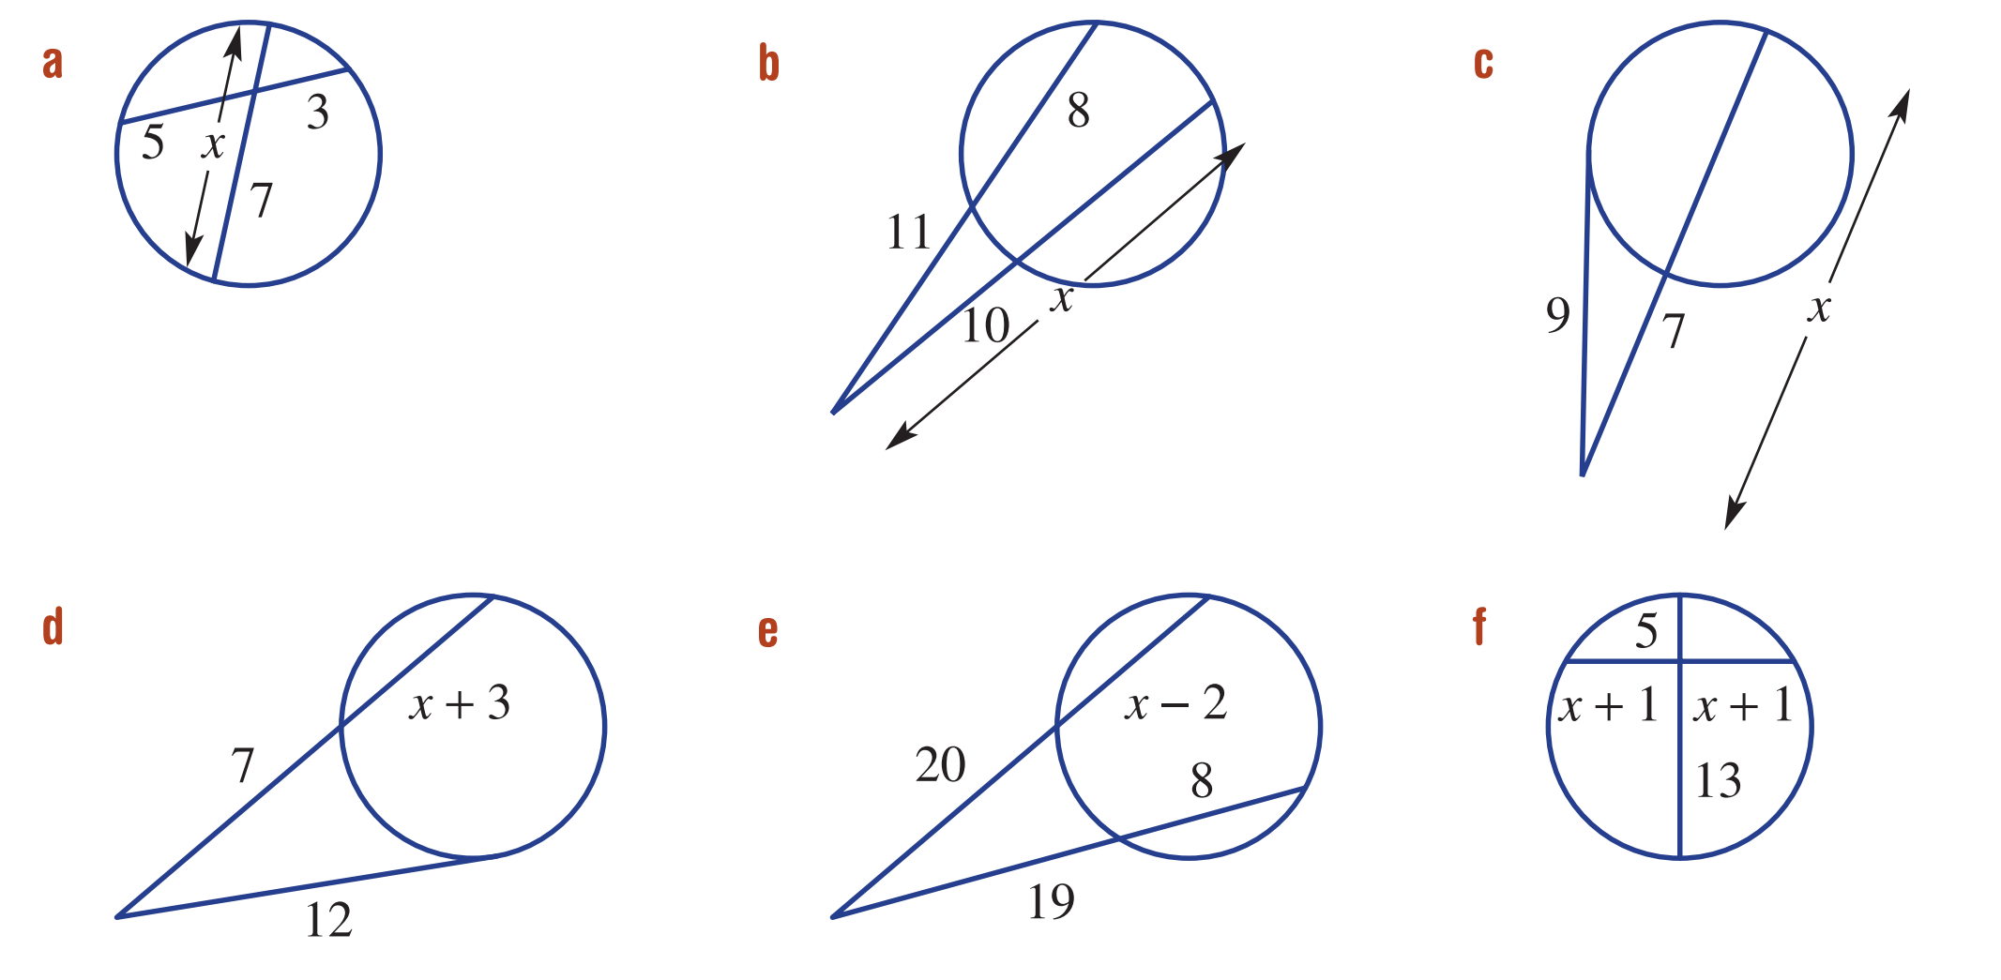  $$\frac{64}{7}$$ | $$\frac{209}{10}$$ | $$\frac{81}{7}$$
$$\frac{74}{7}$$ | $$\frac{153}{20}$$ | $$\sqrt{65}-1$$

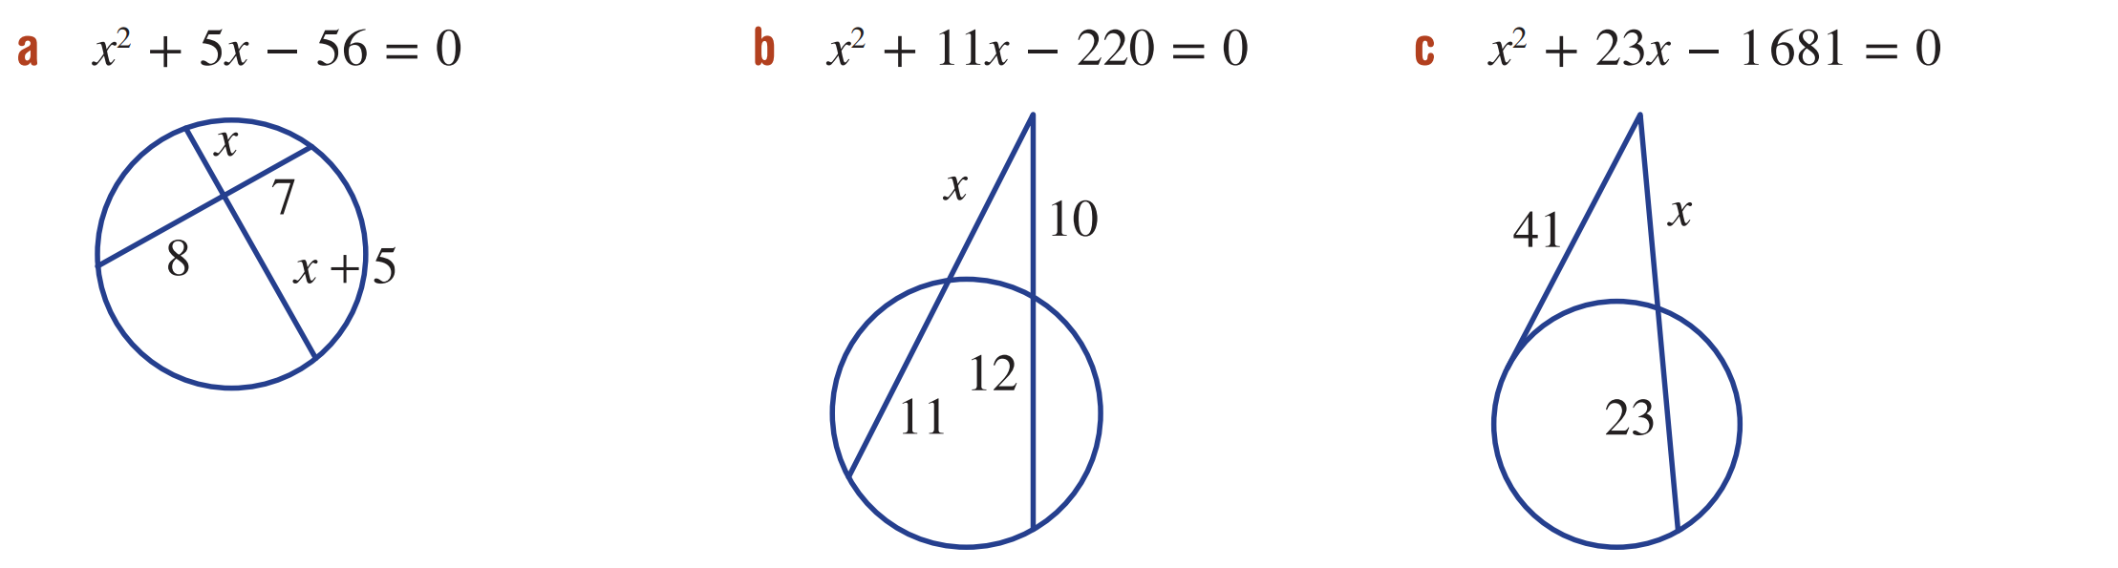
- For each diagram, derive the equation.
- $x^{2}+5x-56=0$  $$x(x+5)=7×8,$$  $$x² +5x=56,$$  $$x² +5x-56=0$$ | - $x^{2}+11x-220=0$  $x(x+11)=10×22$,  $x^{2}+11x=220$,  $$x^{2}+11x-220=0$$ | - $x^{2}+23x-1681=0$  $$x(x+23)=412,$$  $$x^{2}+23x=1681,$$  $$x^{2}+23x-1681=0$$

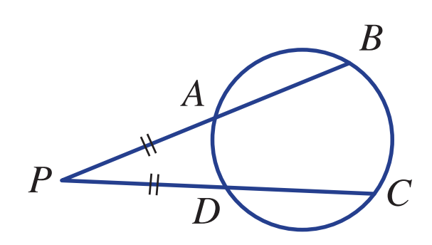
- In this diagram AP = DP. Explain why AB = DC.

AP² =DP×CP and BP² =DP×CP,
so BP=AP.

Mastery
- AB and CD are two chords of a circle that intersect at P.
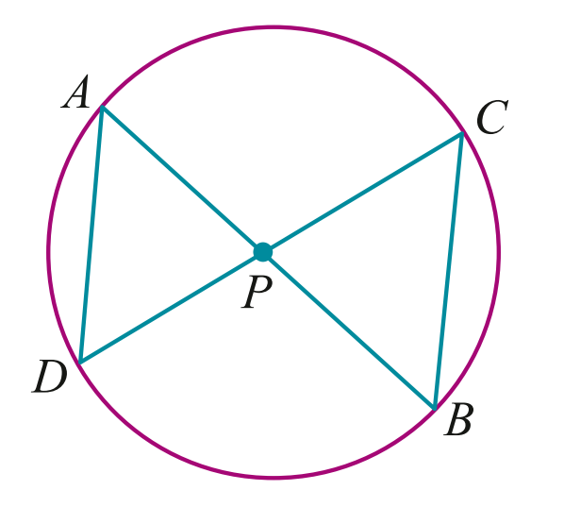
  - Prove that △APD is similar to △CPB

$∠DAB=∠DCB$ (angles subtended at circumference by chord DB equal)
$∠ADC=∠ABC$ (angles subtended at circumference by chord AC equal)
$∠ADP=∠BCP$ (vertically opposite)
$∴△APD ||| △CPB$(equiangular)

  - Write down all the equal ratios of sides in these two triangles.
$$\frac{AP}{PC}=\frac{DP}{PB}=\frac{AD}{CB}$$
  - Hence show that AP × PB = DP × PC
Cross multiply first two fractions from above.

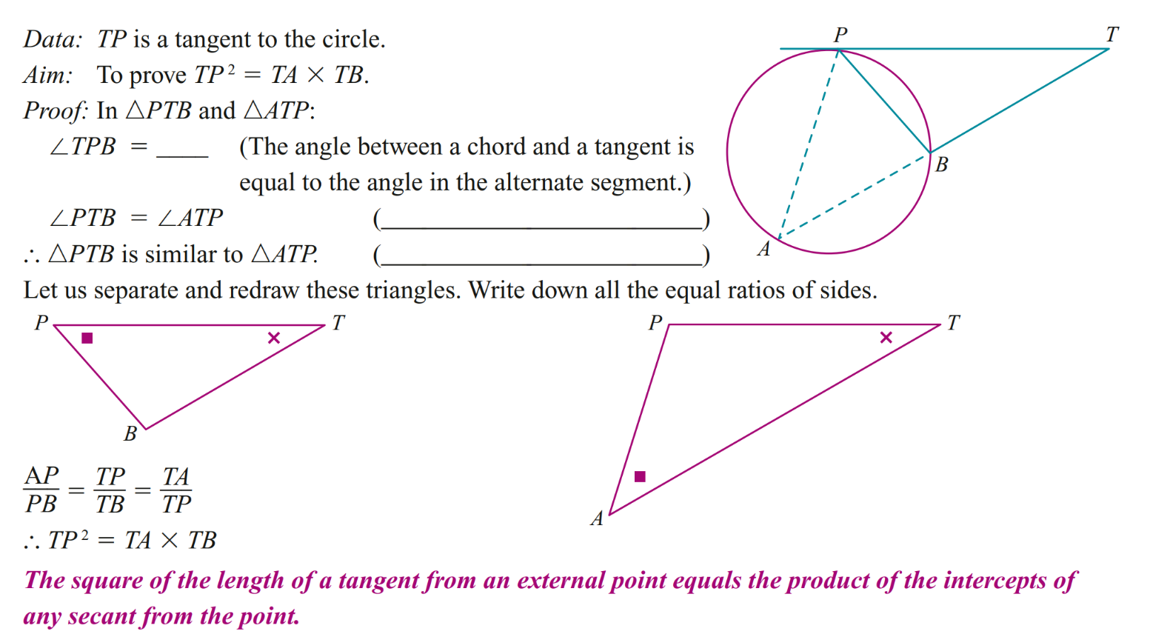
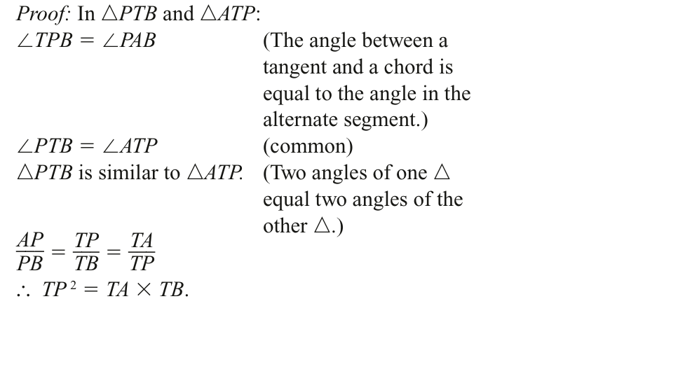

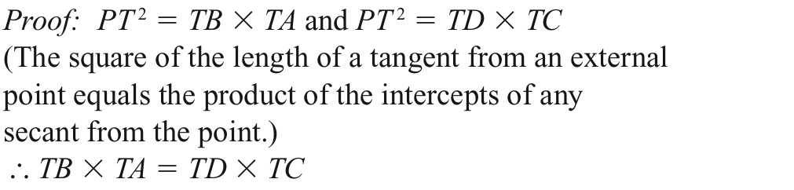
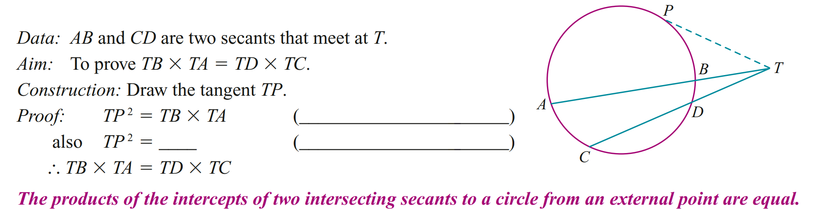

Mixed Practice

Foundation
- Find the value of the pronumeral. You do not need to give reasoning.
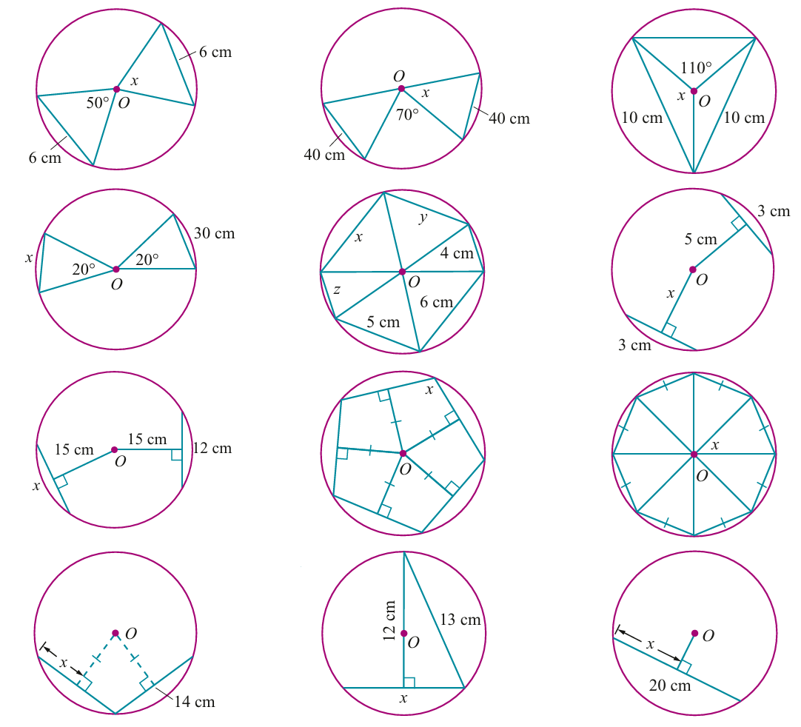  50° | 55° | 125°
96° | 46° | 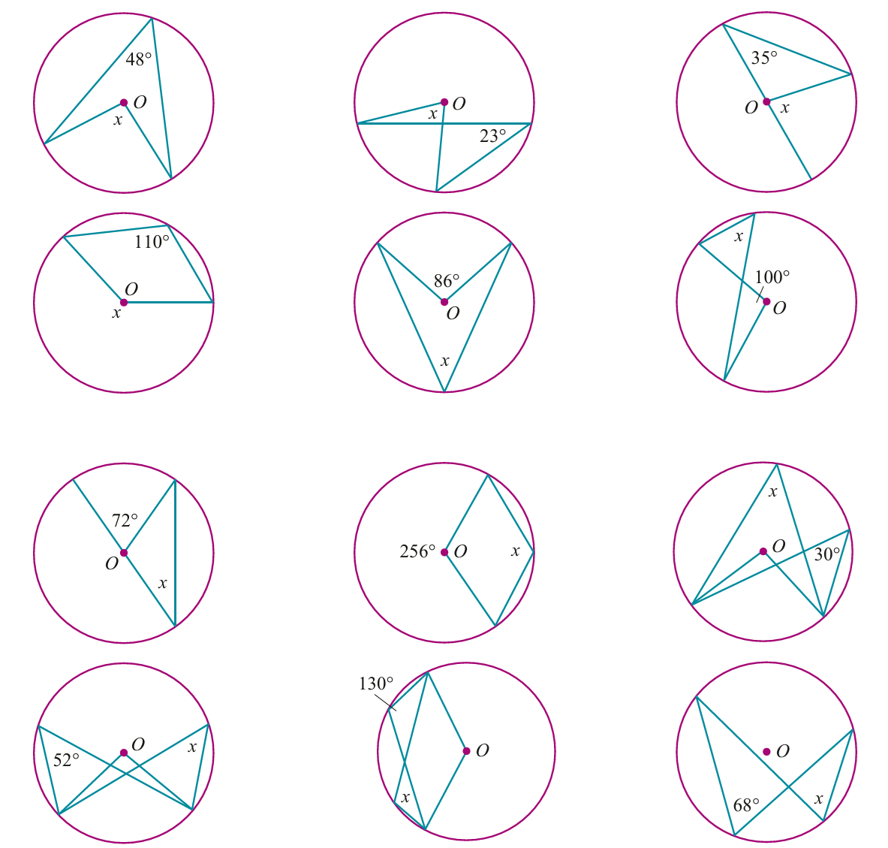  70°
6 cm | 21 cm | 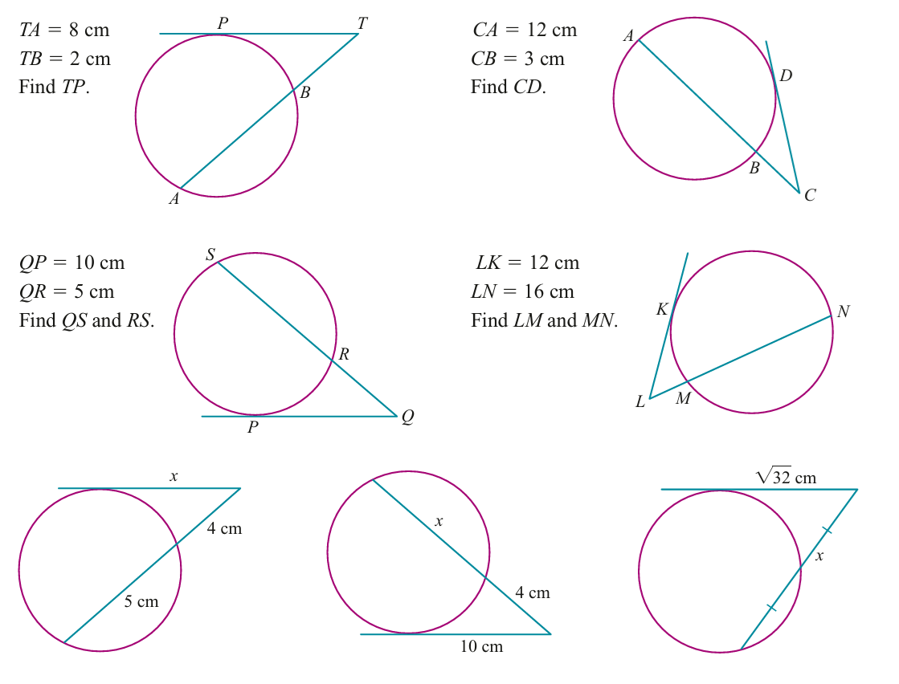  4 cm
$$x=35°, y=25°$$ | 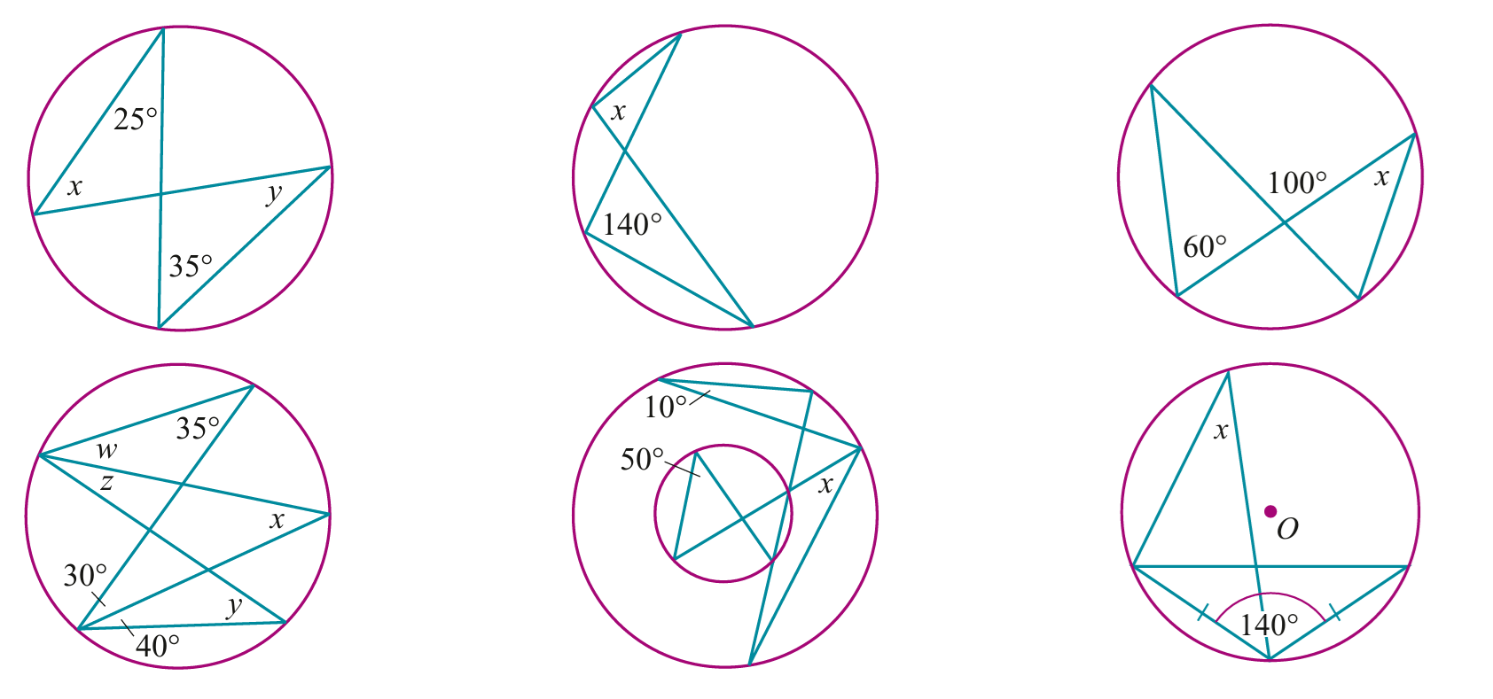  140° | 40°
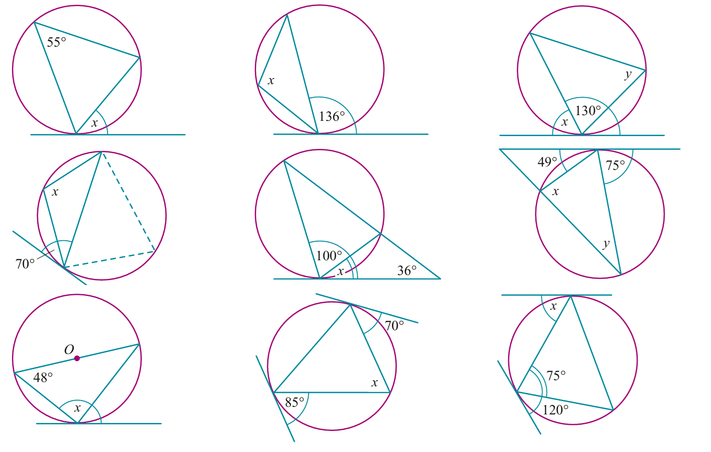  138° | 25° | 60°
30 cm | $x=6$ cm $y=$ 5 cm $z=4$ cm | 5 cm
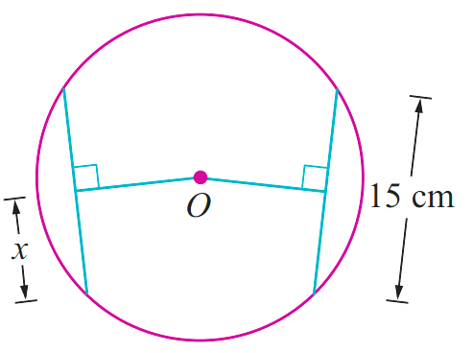  7.5 cm | 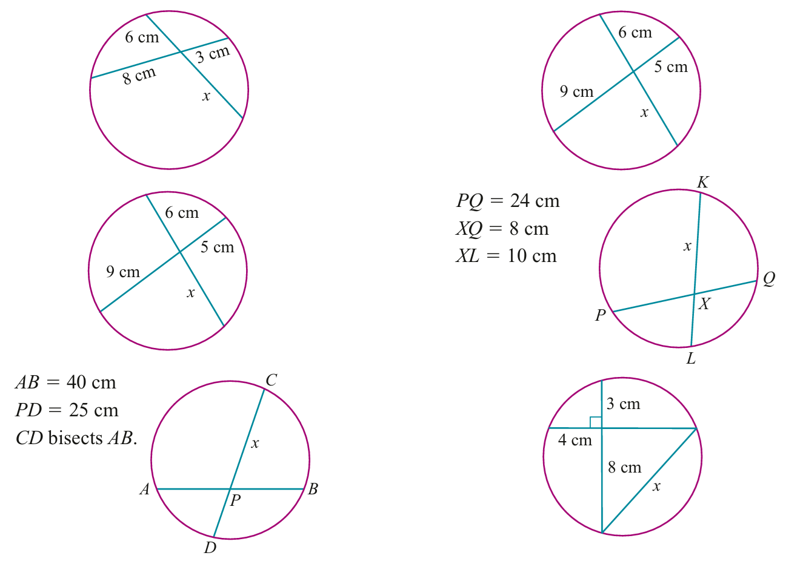  7.5 cm | 10 cm
55° | 136° | $x=50°, y=50°$
36° | 128° | 30°
45° | 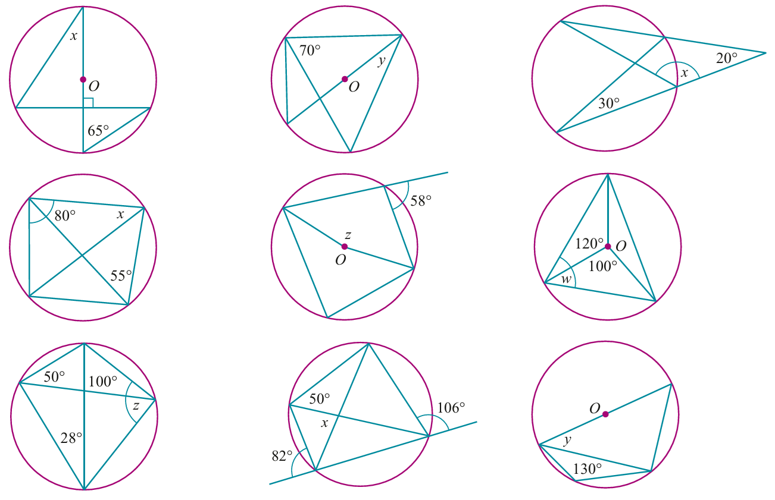  116° | 70°
50° | $x=40°, y=40°$ | 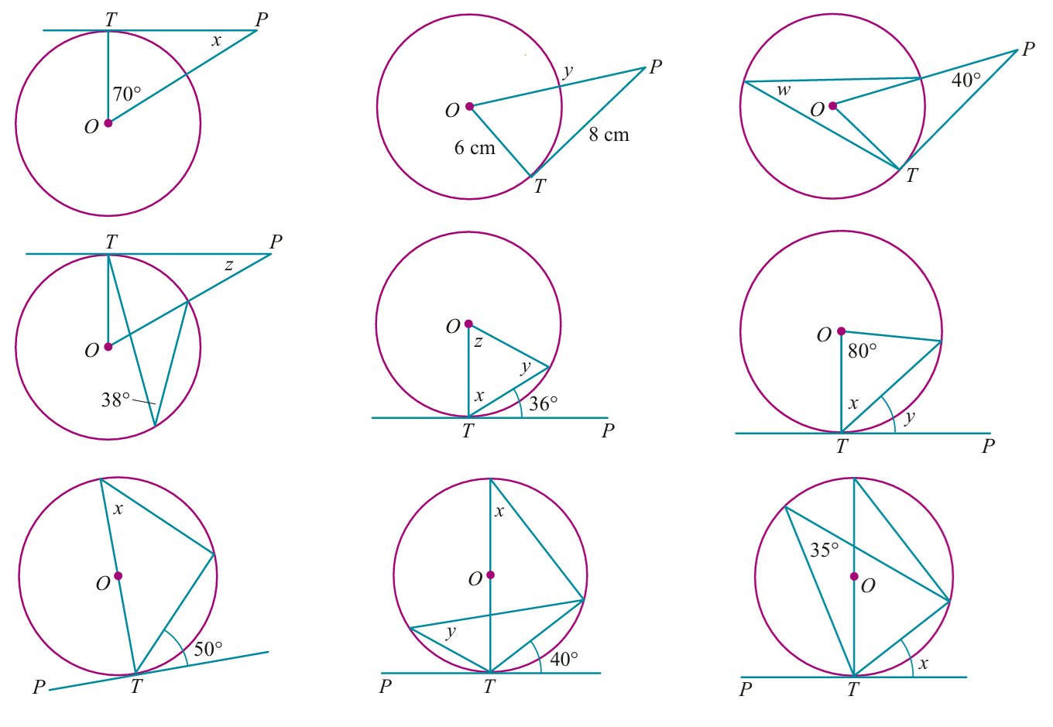  35°
12 cm | 108° | 45°
220° | 43° | 50°
7 cm | 10 cm | 10 cm
$$25°$$ | 20° | 130°
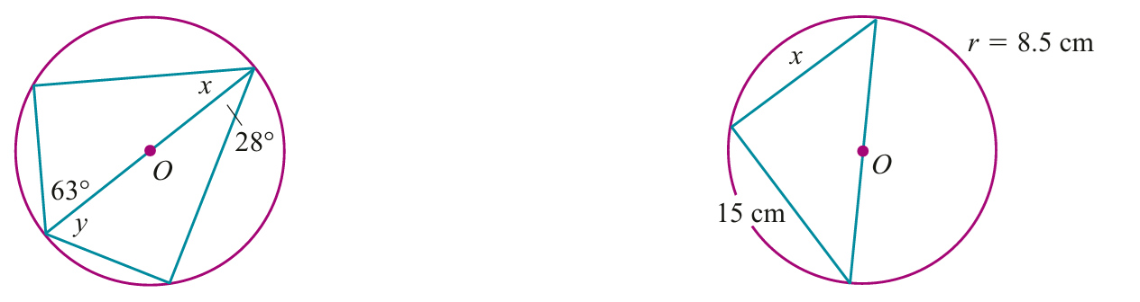  $$x=27°, y=62°$$ | 8 cm | 4 cm
20° | 10 cm | 25°
52° | 130° | 68°
14° | $x=54°, y=54°, z=72°$ | $x=50°, y=40°$
- $AB=40$ cm,$PD=$ 25 cm  $CD$ bisects $AB$  16 cm | - $PQ=24$ cm, $XQ=$ 8 cm  $XL=10$ cm  12.8 cm | - $TA=$ 8 cm, $TB=$ 2 cm  Find $TP$  4 cm
110° | 44° | $x=75°, y=49°$
- $CA=12$ cm, $CB=$ 3 cm  Find $CD$  6 cm | - $QP=10$ cm, $QR=$ 5 cm  Find $QS$ and $RS$  QS = 20 cm, RS = 15 cm | - $LK=12$ cm,$LN=16$ cm  Find $LM$ and $MN$  LM = 9 cm, MN = 7 cm
$$w=30°, x=35°, y=35°, z=40°$$ | 40° | 20°
80° | $$x = 60°, y = 60°, z = 60°,$$  $$w = 300°, v = 150°$$ | 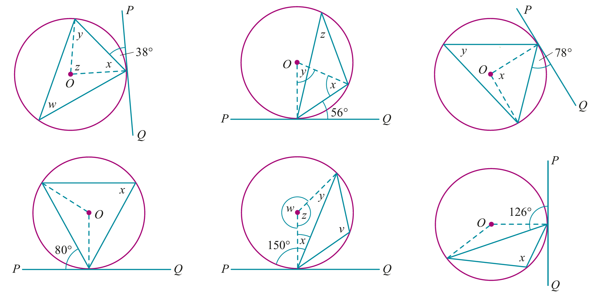  126°
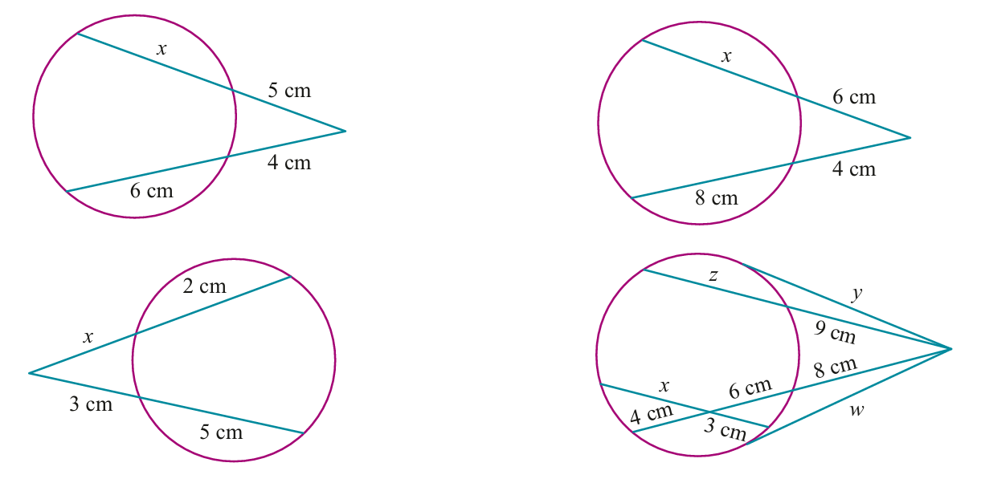  2 cm | 4 cm | $w=12$ cm, $x=8$ cm  $y=12$ cm, $z=7$ cm
78° | 76° | 40°
$$x = 52°, y = 52°, z = 76°, w = 38°$$ | $$x = 34°, y = 112°, z = 56°$$ | $x = 156°, y = 78°$

Development
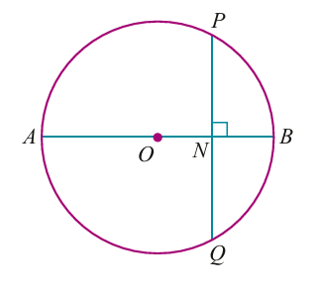
- AN = 18 cm and NB = 8 cm. Find the length of PQ.

24 cm
- The figure shows two concentric circles, centre O. OL = 13 cm, OK = 15 cm and LM = 10 cm.
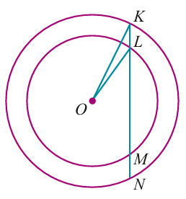
Find KN.

18 cm
- A hemispherical bowl has a diameter of 10 cm.
Water is poured into the bowl until its surface is 3 cm below the top of the bowl as shown.
Find the diameter of the water surface.
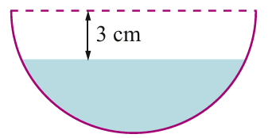

8 cm
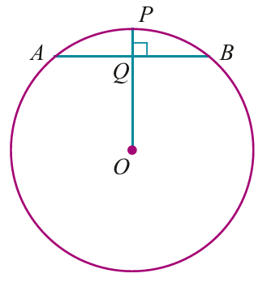
- OP is perpendicular to the chord AB. If AB = 14 cm and PQ = 1 cm, find the radius of the circle.

25 cm
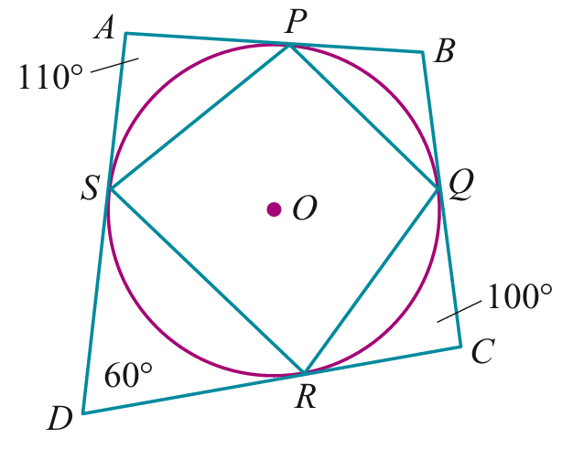
- The circle touches the sides of the quadrilateral ABCD at P, Q, R and S as shown. Find the angles of the quadrilateral PQRS.

$$∠P=100°, ∠Q=95°, ∠R=80°, ∠S=85°$$
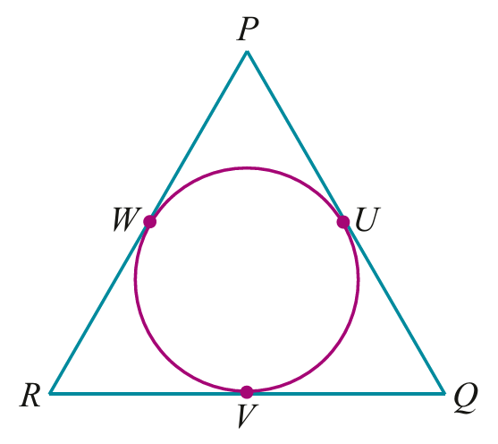
- PQ, QR and RP are tangents. If PR = 9 cm, RW = 5 cm and RQ = 12 cm, find PQ.

$PQ=11$ cm
- I is the incentre of △PQR. RQ = 8 cm, PR = 9 cm and PQ = 7 cm. Find RB.
Hint: set up a system of 3 simultaneous equations.
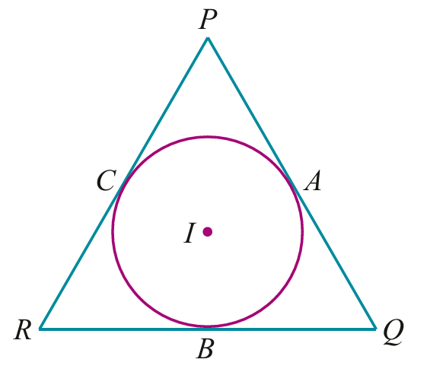

$RB=5$ cm
- Two circles of radii 2 cm and 7 cm have their centres 13 cm apart.
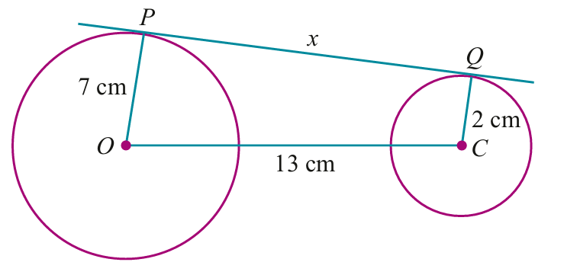
Find the length of the direct common tangent PQ.

12 cm
- A person of height h metres stands on the surface of Earth, which is assumed to be a
sphere of radius R.
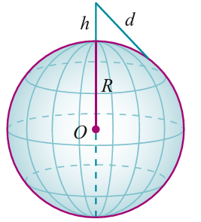
  - Show that the distance, $d$, to the horizon is given by $d=\sqrt{h^{2}+2hR}$

$d^{2}=h(h+2R)$
The square of a tangent to a circle from an external point is
the product of the intercepts of any secants from the point.
  - Calculate the distance across level ground to the horizon that can be seen by a person of height 1.8 m. Use $R=6400$ km.

4800.000338 m
  - The formula in part a is often given as $d≈\sqrt{2hr}$. Why might this be the case?
$h^{2}$ is extremely small compared to $2hR$.

Exam Questions
- 2019 HSC Extension 1 Band 3
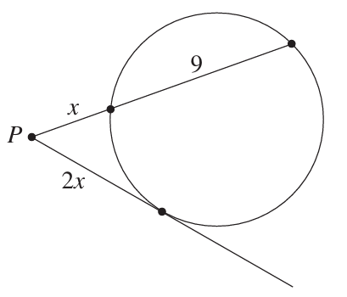
From the point P outside a circle, a secant and a tangent to the circle are constructed a shown in the diagram:
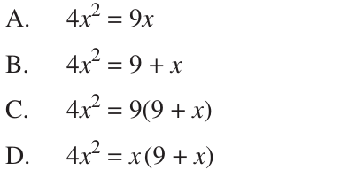
Which equation is satisfied by $x$?

D

- 2017 HSC Extension 1 Band 3
The points $A$, $B$, $C$ and $D$ lie on a circle and the tangents at $A$ and $B$ meet at $T$.
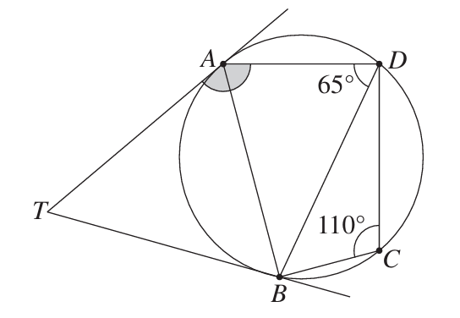
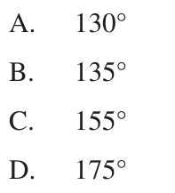
What is the value of $∠TAD$?

B
- 2019 HSC Extension 1 Band 4
The line segment AB is a diameter of the circle, centred at O. The line CD is the tangent to the circle at C and BD is perpendicular to CD, as shown in the diagram.
Prove that $∠$ABC = $∠$CBD
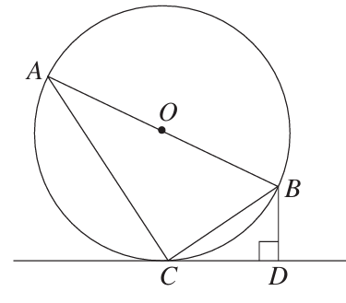
Let ∠BCD = $α$
∴ ∠CAB $= α$ (angle in alt segment)
∠ACB = 90° (angle in a semi-circle)
∴ ∠ABC = 90 $- α$ (angle sum △)
∠CBD = 90$- α$(angle sum △)
∴ ∠ABC = ∠CBD

- 2017 HSC Extension 1 Band 4
The points $A$, $B$ and $C$ lie on a circle with centre $O$, as shown in the diagram.
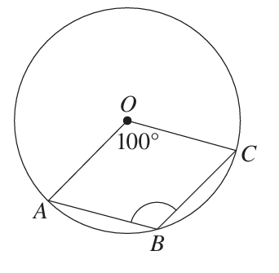
The size of $∠AOC$ is 100°. Find the size of $∠ABC$, giving reasons.

Reflex $∠AOC = 360° - 100°$ (angle of revolution)
$$= 260°$$
$∠ABC =\frac{1}{2}× reflex ∠AOC$ (angle at centre equals twice the angle at circumference standing in the same arc)
$$=\frac{260}{2}$$
$$= 130°$$

- 2015 HSC Extension 1 Band 4
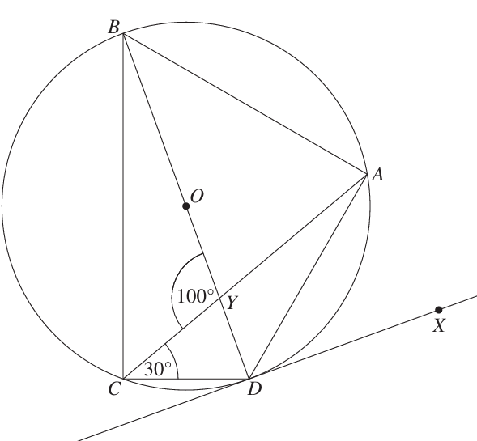
aaaIn the diagram, the points $A, B, C$ and $D$ are on the circumference of a circle, whose centre $O$ lies on $BD$. The chord $AC$ intersects the diameter $BD$ at Y$.$ The tangent at $D$ passes through the point $X$. It is given that $∠CYB = 100°$ and $∠DCY = 30°$
  - What is the size of $∠$ACB?

∠ACB + ∠ACD = 90° (Angle in a semi-circle is a right angle)
∠ACB + 30° = 90°
∴ ∠ACB = 60°
  - What is the size of $∠$ADX?

∠ADX = ∠ACD (alternate segment theorem) = 30°
  - Find, giving reasons, the size of $∠$CAB.

∠CDY + ∠YCD = 100° (∠BYC, exterior ∠ of △CDY)
∴ ∠CDY = 70° ∠CAB = ∠CDB (Angles standing on same chord at the circumference are equal)
∴ ∠CAB = 70°

- 2018 HSC Extension 1 Band 5
The diagram shows quadrilateral ABCD and the bisectors of the angles at A, B, C and D.
The bisectors at A and B intersect at the point P. The bisectors at A and D meet at Q.
The bisectors at C and D meet at R. The bisectors at B and C meet at S.
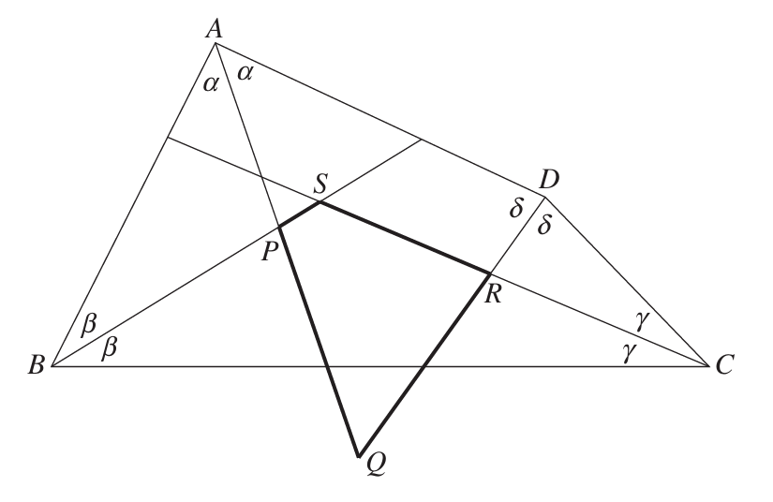
Show that PQRS is a cyclic quadrilateral.

$$Let α =\frac{1}{2}∠A, β =\frac{1}{2}∠B$$
$$γ =\frac{1}{2}∠C, δ =\frac{1}{2}∠D$$

Then $2α + 2β + 2γ + 2δ = 360°$ (∠ sum quadrilateral)
$$∴ α + β + γ + δ = 180°$$
$∠PSR = ∠BSC = 180° - (β + γ)$ (∠ sum of △BSC)
$∠PQR = ∠AQD = 180° - (α + δ)$ (∠ sum of △AQD)
$$∴ ∠PSR + ∠PQR = 2 × 180° - (α + β + γ + δ)$$
$$= 2 × 180° - 180°$$
$$= 180°$$
∴ PQRS is cyclic (opposite angles are supplementary)

- 2016 HSC Extension 1 Band 5
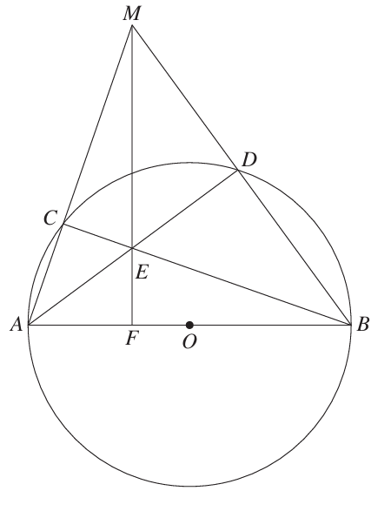
The circle centred at O has a diameter AB. From the point M outside the circle the line segments MA and MB are drawn meeting the circle at C and D respectively.
The chords AD and BC meet at E. The line segment ME produced meets the diameter AB at F.
  - Show that $CMDE$ is a cyclic quadrilateral.

$∠ADB = 90°, ∠BCA = 90°$ (∠ in a semicircle)
$∠MDE = 90°$ (∠ sum, straight line)
$∴ CMDE$ is a cyclic quadrilateral (Exterior ∠ACB equal to opposite interior ∠MDE)

  - Hence, or otherwise, prove that MF is perpendicular to AB.
Construct CD
Let $∠ABC = x$
$∴ ∠ADC = x$ (∠s in the same segment)
Similarly $∠CME = x$
$∠CAB = 90° - x$ (∠ sum △ABC)
∴ $∠MFA = 180° - ∠CME - ∠CAB$ (∠ sum △MFA)
$$= 180° - x- (90° - x°)$$
$$= 90°$$
$$∴ MF ⊥ AB$$

- 2016 HSC Extension 2 Band 5
The circle centred at O has diameter AB. A point P on AB produced is chosen so that PC is a tangent to the circle at C and BP = BC. The tangents to the circle at A and C meet at Q.
Prove that $OP=OQ.$
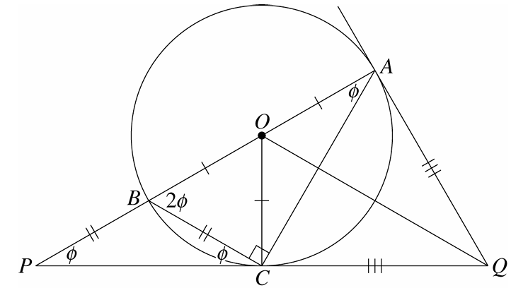
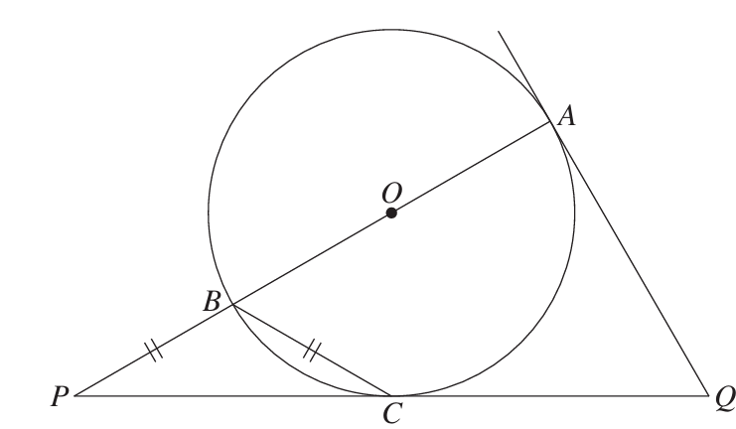

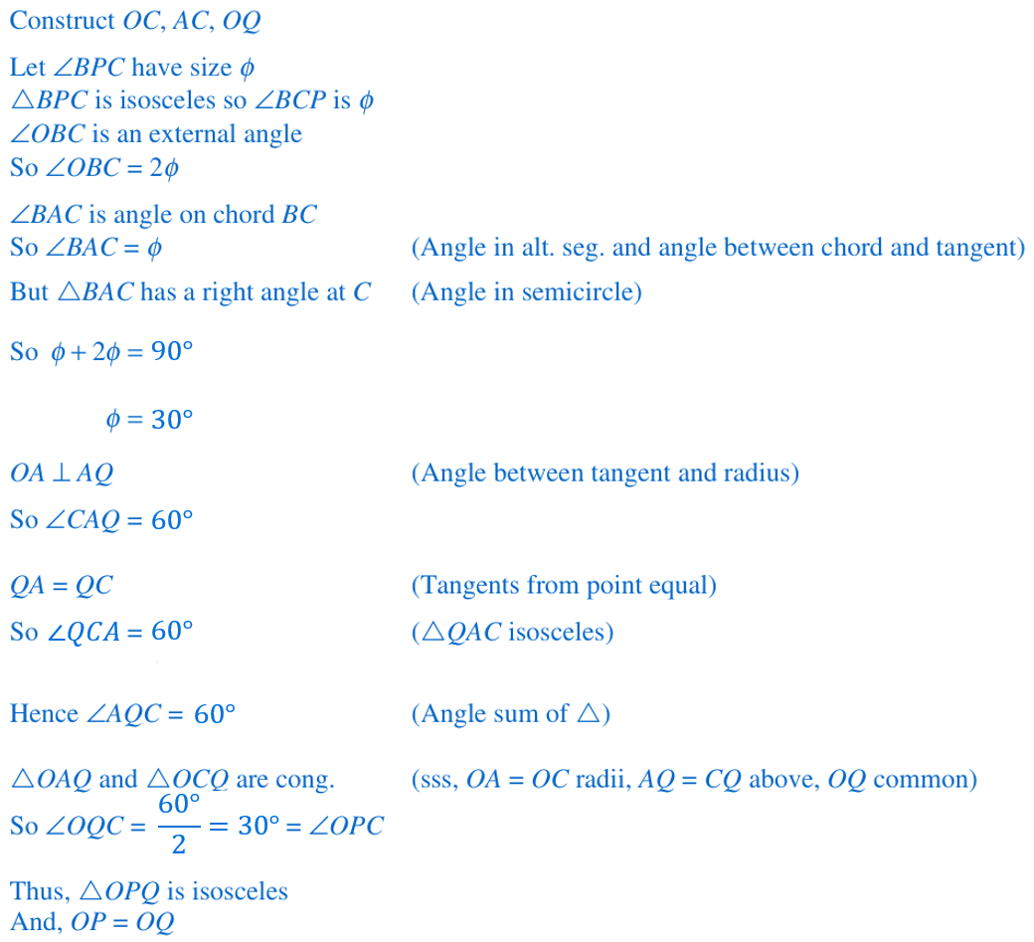

Learning Intention

- Review (Questions as relevant to the planned examples as possible)
- Recall

- Identify

- Definition | Formula | Procedure

- Identify Language | Decision
Scenario
✖ |  | ✔ |  |  | ✔ |  |  | ✖
✖ | ✔ |  |  | ✔ |  | ✔ |  |  | ✖
Testing Sequence

- Interpret Transformation
Scenario
Testing Sequence

- Example Success Criteria
Scenario
Worked example |  | Checks for listening

- Guided Practice
Test the same skill as the I Do but still require genuine thinking - not just pattern matching.
Sequence of examples varying critical features

- Key Ideas
- Fact atoms
- Procedure

$$proj_{b}a$$

$$proj_{u}v$$

Foundation

$$Type equation here.$$ | $$Type equation here.$$

$$Type equation here.$$ | $$Type equation here.$$ | $$Type equation here.$$

$$Type equation here.$$ | $$Type equation here.$$ | $$Type equation here.$$ | $$Type equation here.$$

- Desmos

- GeoGebra

Symbols:
✔
¯¯¯
✖

$$\overset{̰}{a}$$

